**Lab File**

**Programs Using C**

**(CSIT 124)**

**DEPARTMENT OF COMPUTER SCIENCE AND ENGINEERING**



Submitted to: Dr. Nisha Pahal Submitted by: Anish Kumar Singh

Amity School Of Engineering and technology

Amity University Uttar Pradesh

Noida -201301

**Index:-**

Date:9/10/2020

1).Print Hello world program:-

2).Write a program to find the area of a circle

3).Write a program to add two integers

4).Write a program to print ASCII value

5).Write a program to multiply floating point numbers

Date:16/10/2020

1).Write a program to swap two variables using a third variable

2).Write a program to swap two variables without using a third variable

3).Write a program to convert a given integer (in seconds) to hours, minutes and seconds.

Date:23/10/2020

1).Write a program to perform a division between 2 integers using *int* keyword.

2).Write a program to perform division between 2 integers using *float* keyword.

3).Write a program to perform division between 2 float numbers until 2 decimal places.

4).Write a program to find square root of a number using <math.h> header file.

Date:6/11/2020

1).Write a program to enter integers until he/she enters a negative number or a zero

2).Write a program to print all the odd numbers from 1 to 20 using *continue*

3).Write a program to find maximum among 2 numbers

4).Write a program to find maximum among3 numbers

5).Write a program to check whether a number is negative, positive, or zero

6).Write a program to check whether a number is even or odd

7).Write a program to input any character and check whether it is alphabet, digit, or special character

8).Write a program to find all roots of a quadratic equation

Date:13/11/2020

1).WAP to check whether a number is an Armstrong number

2).WAP to check whether a number is a strong number or not

3).WAP to find the factorial of a number

4).WAP for Fibonacci series

Date:20/11/2020

1).WAP to check whether a year is a leap year or not.

2).Programs using for loop:

* WAP that uses nested for loop in C to put a multiplication table
* WAP to print a natural number in range
* WAP to print natural numbers in reverse in the given range
* WAP to print alphabets from a-z
* WAP to find the power
* WAP to find the sum of odd numbers from 1 to n
* WAP to check whether a number is perfect number or not
* WAP to check whether a number is prime or not

3).Programs using while loop:

* WAP to print the first and last digit of a number, also find the sum
* WAP to find the sum and product of digits of a number
* WAP to convert binary number to decimal
* WAP to find the LCM of two numbers

4).WAP to print a table of number 2 using do-while loop.

Date:21/11/2020

1).WAP to read and print the array elements

2).WAP to find the sum of all the array elements

3).WAP to find the largest element in the array

4).WAP to insert all the elements of one array into another

5).WAP to print negative numbers in array

6).WAP to print array in reverse

7).WAP to add two matrix

8).WAP to perform matirx multiplication using 2D arrays

9).WAP to check whether a given matrix is sparse matrix or not

Date:27/11/2020

1).Programs using functions:

* to find the cube of any number
* to find diameter, circumference and area of circle
* to find maximum and minimum between two numbers
* to check whether a number is even or odd
* to check whether the number is prime, armstrong or perfect number
* to print all strong numbers between given interval

2).Programs using recursion:

* to find the power of any number
* to print all the natural numbers between 1 to n

Date:8/12/2020

1). WAP to compute the size of structure usinf sizeof operator

2).WAP to store and display student information (Name, Roll Number & Marks) using structures

3).WAP to store and print the student information (Name, Roll Number & Marks) using nested structures

4).WAP to store and print the record(Name, Roll Number & Percentage0 of 5 students usinf array of structure

5).WAP to create a structure called student to store the name roll number and marks of 3 students and calculate the average marks of each student

6).WAP to perform the addition operation by passing structure members to functions

7).WAP to declare and initialize a union

Date:11/12/2020

1).WAP to find the area of rectangle using structures(write a function that accepts a structure rectangle and then computes the area)

2).WAP to use enum in switch case statemant to print which day is today. Consider the enum type named as week days, and it xcontains the name of all the seven days

3).WAP to create, initialize and use pointer variable

4).WAP to demeonstrate the use of & and *

5).WAP to perform arithmaetic operations using pointers

6).WAP to find the area of square usig pointers

7).WAP to reverse a number using pointers

8).WAP to print the factorial of an integer using pointers

**1).Print Hello world program:-**

#include <stdio.h>

int main()

{

printf("Hello World");

return 0;

}

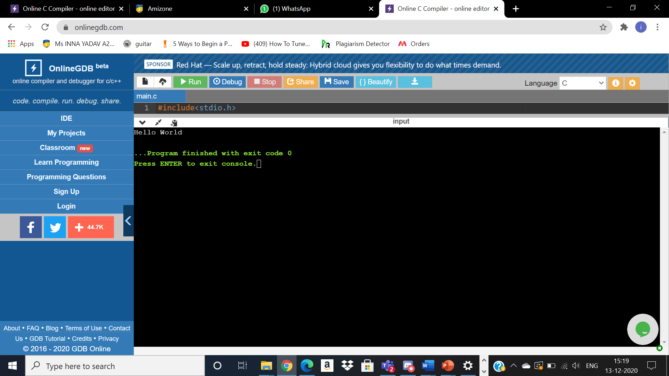

**2).Write a program to find the area of a circle:-**

#include <stdio.h>

int main()

{

float a,area;

printf("Enter the radius of circle: ");

scanf("%f",&a);

area=3.14*a*a;

printf("Area = %f",area);

return 0;

}

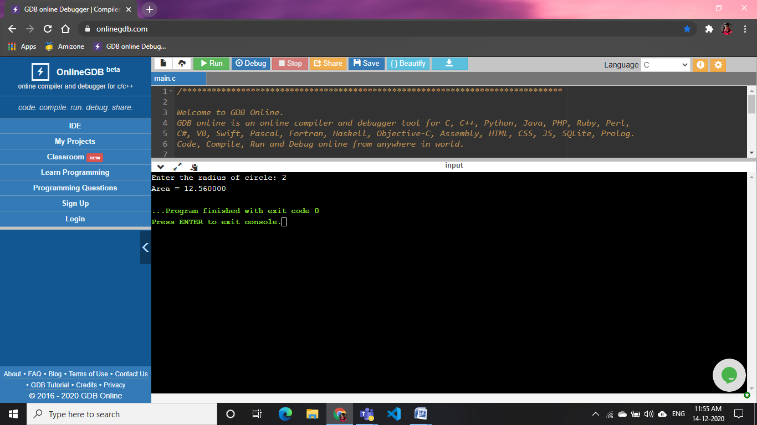

3).Write a program to add two integers:-

#include <stdio.h>

int main()

{

int a,b;

printf("Enter Value of a and b to add them:\n");

printf("a:-");

scanf("%d",&a);

printf("b:-");

scanf("%d",&b);

printf("a+b=%d",a+b);

return 0;

}

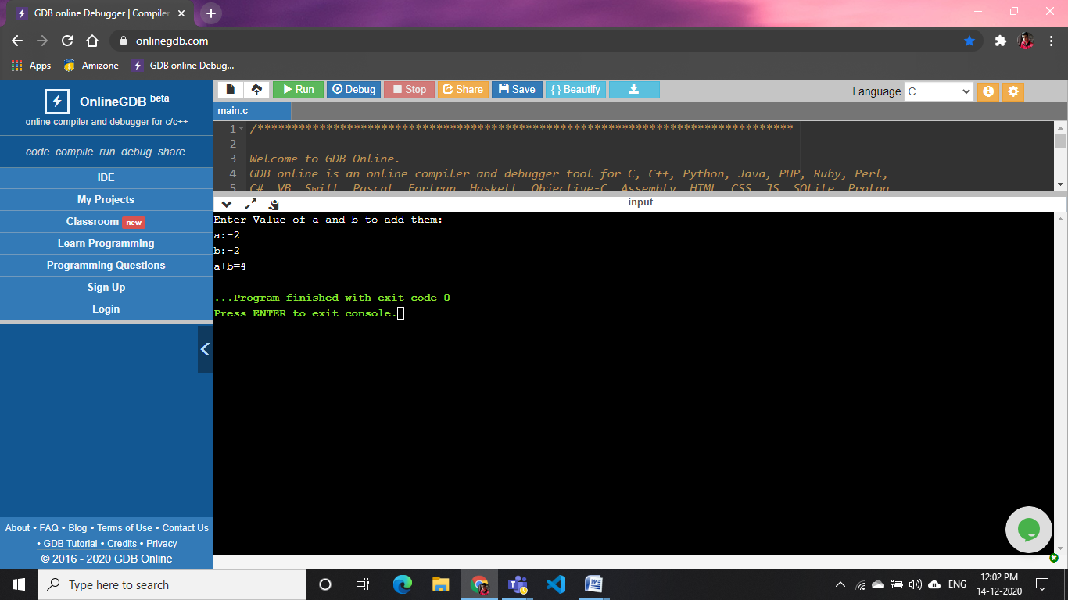

**4).Write a program to print ASCII value:-**

#include <stdio.h>

int

main ()

{

char c;

printf ("Enter a character: ");

scanf ("%c", &c);

printf ("ASCII value of %c = %d", c, c);

return 0;

}

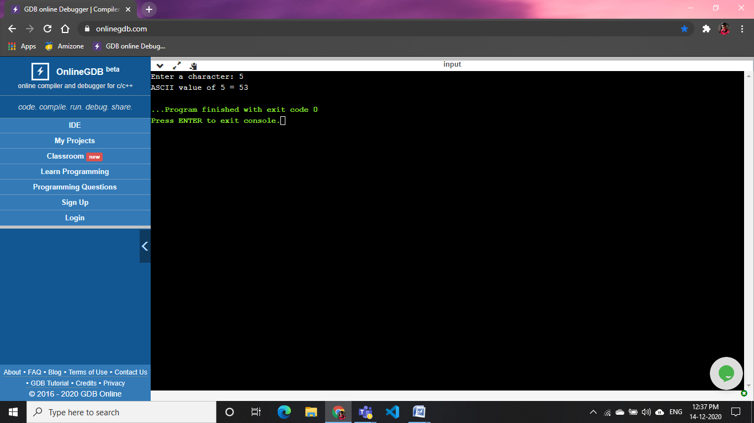

**5).Write a program to multiply floating point numbers:-**

#include <stdio.h>

int main()

{

float a,b;

printf("Enter any decimal to do multiplication\n");

printf("a= ");

scanf("%f",&a);

printf("b= ");

scanf("%f",&b);

printf("a X b=%f",a*b);

return 0;

}

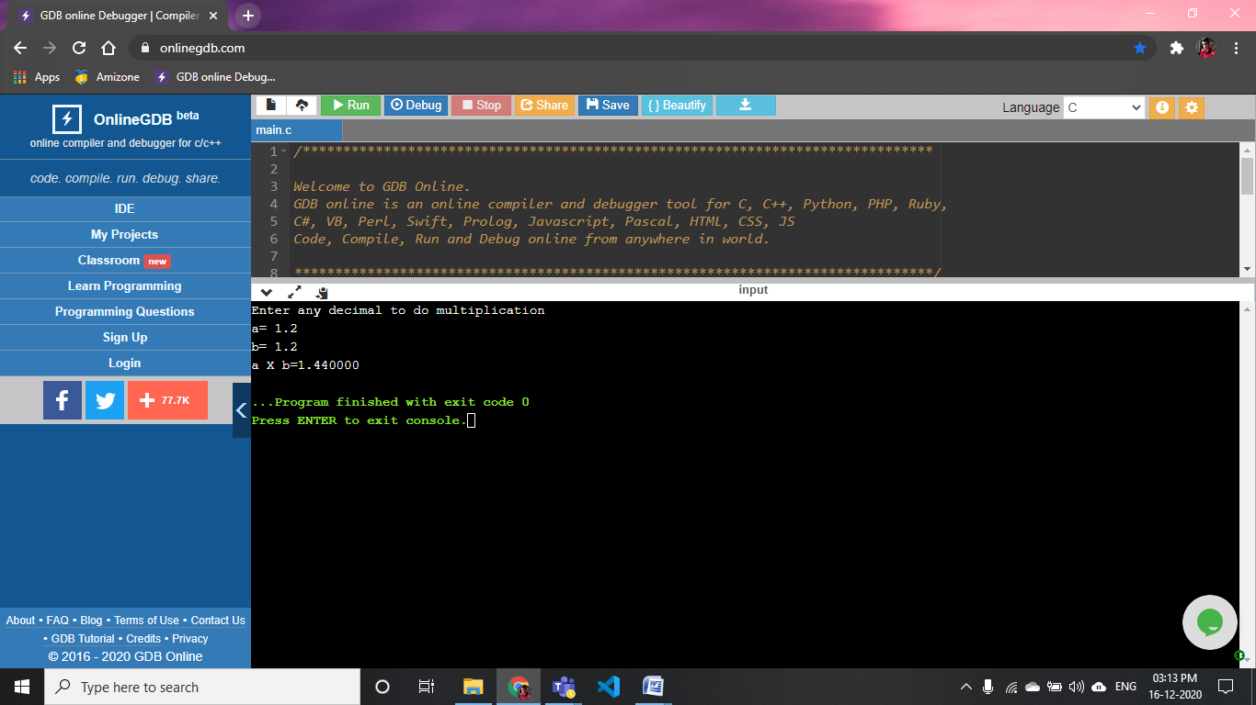

**6).Write a program to swap two variables using a third variable**

#include <stdio.h>

int main()

{

int a,b,temp;

printf("Enter any two values to swap\n");

printf("a= ");

scanf("%d",&a);

printf("b= ");

scanf("%d",&b);

printf("previously\n a=%d\nb=%d",a,b);

temp=a;

a=b;

b=temp;

printf("\nNow\n a=%d\nb=%d\n",a,b);

return 0;

}

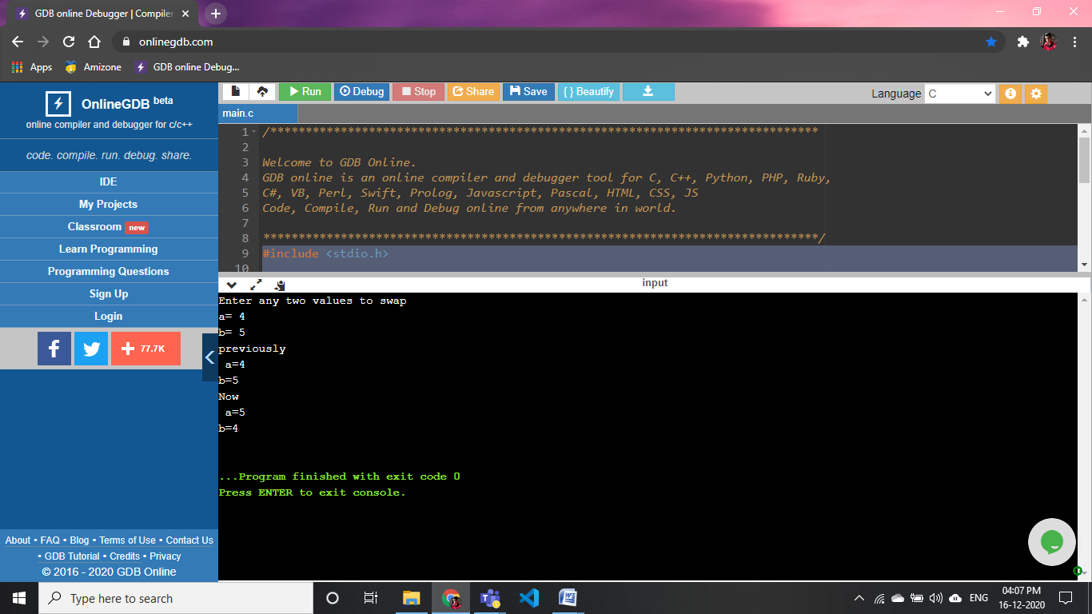

**7).Write a program to swap two variables without using a third variable**

#include <stdio.h>

int main()

{

int a,b;

printf("Enter any two values to swap\n");

printf("a= ");

scanf("%d",&a);

printf("b= ");

scanf("%d",&b);

printf("previously\n a=%d\nb=%d",a,b);

printf("\nNow\n a=%d\nb=%d\n",b,a);

return 0;

}

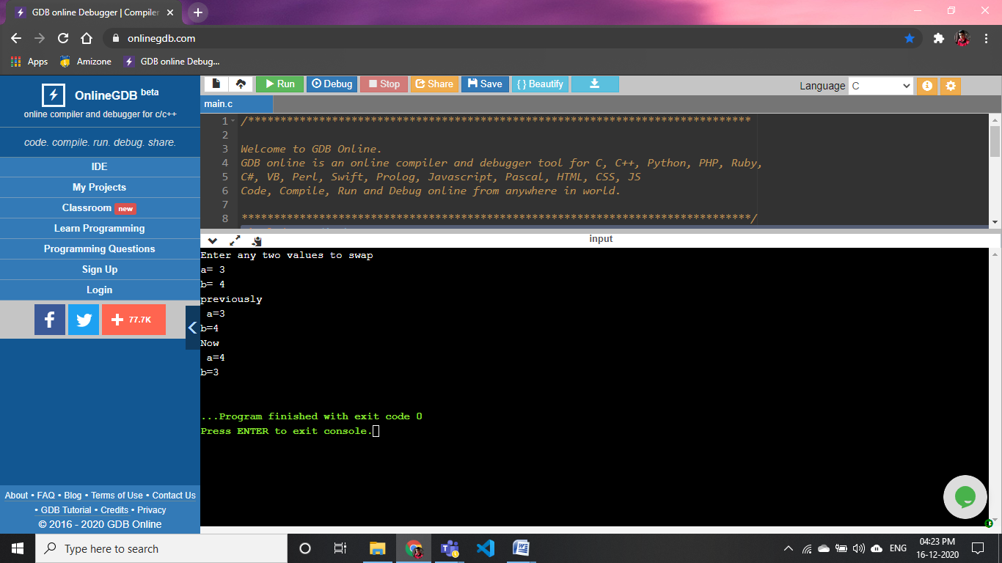

**8).Write a program to convert a given integer (in seconds) to hours, minutes and seconds.**

#include <stdio.h>

int main()

{

int a;

printf("Enter the time in second\n");

scanf("%d",&a);

printf("\nsecond: %d",a);

printf("\nHour: %d",a/3600);

printf("\nMinute: %d",a/60);

return 0;

}

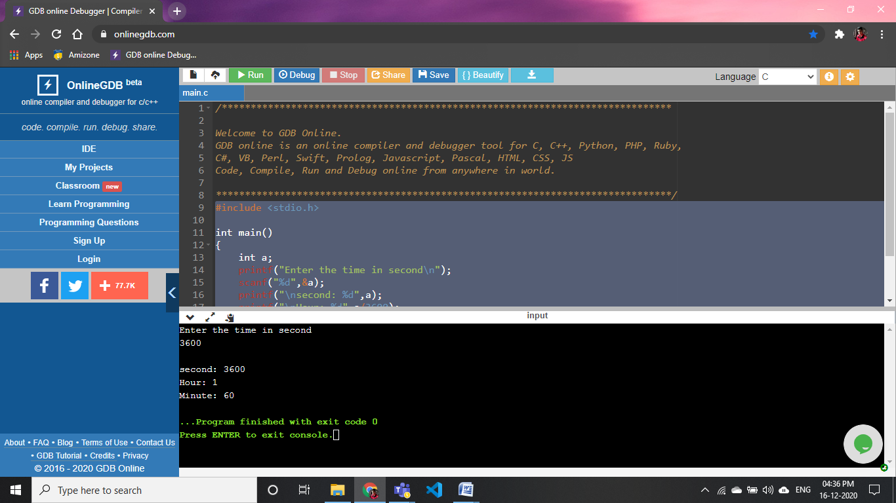

**9).Write a program to perform a division between 2 integers using *int* keyword.**

#include <stdio.h>

int main()

{

int a,b,c;

printf("Enter the dividend: ");

scanf("%d",&a);

printf("Enter the divisor: ");

scanf("%d",&b);

c=a/b;

printf("a/b= %d",c);

return 0;

}

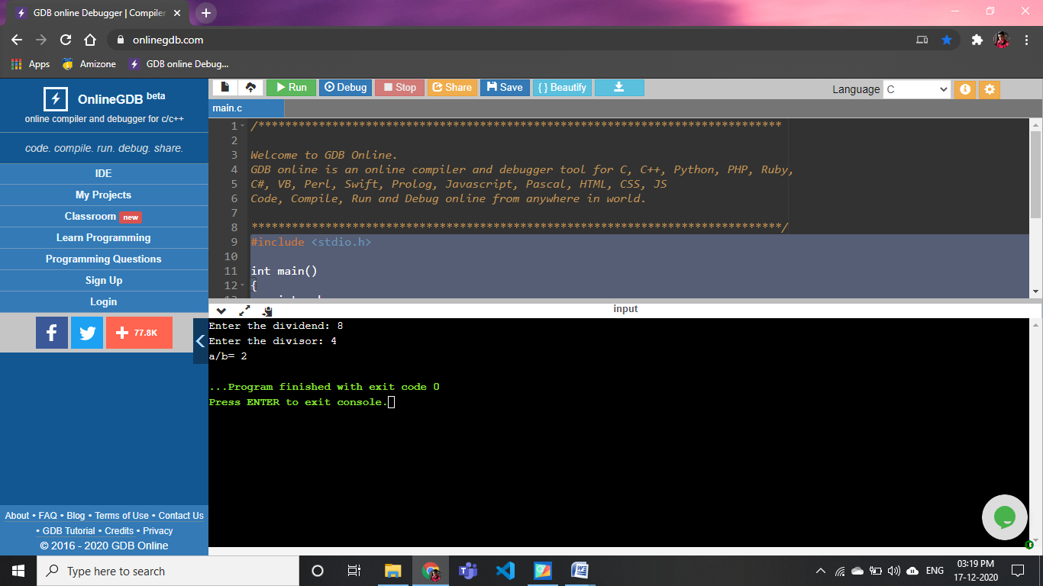

**10).Write a program to perform division between 2 integers using *float* keyword**

#include <stdio.h>

int main()

{

float a,b,c;

printf("Enter the dividend: ");

scanf("%f",&a);

printf("Enter the divisor: ");

scanf("%f",&b);

c=a/b;

printf("a/b= %f",c);

return 0;

}

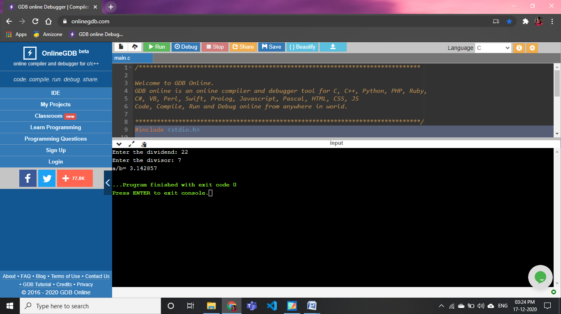

**11).Write a program to perform division between 2 float numbers until 2 decimal places.**

#include <stdio.h>

int main()

{

float a,b,c;

printf("Enter the dividend: ");

scanf("%f",&a);

printf("Enter the divisor: ");

scanf("%f",&b);

c=a/b;

printf("a/b= %.2f",c);

return 0;

}



12).Write a program to find square root of a number using <math.h> header file.

#include <stdio.h>

#include<math.h>

int main()

{

float a;

printf("Enter any value to get squreroot: ");

scanf("%f",&a);

printf("squreroot=%f",sqrt(a));

return 0;

}

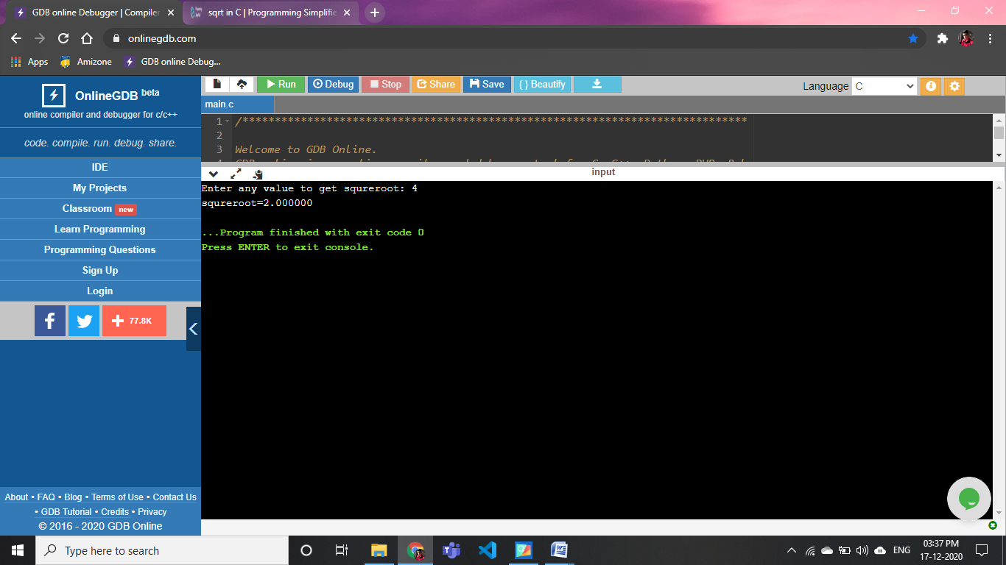

**13).Write a program to enter integers until he/she enters a negative number or a zero**

#include <stdio.h>

#include<math.h>

int

main ()

{

int a;

printf("Enter any -ve value or 0 to terminate the code: ");

scanf("%d",&a);

while(a>0)

{

printf("Enter any -ve value or 0 to terminate the code: ");

scanf("%d",&a);

}

printf("Code is terminated");

return 0;

}

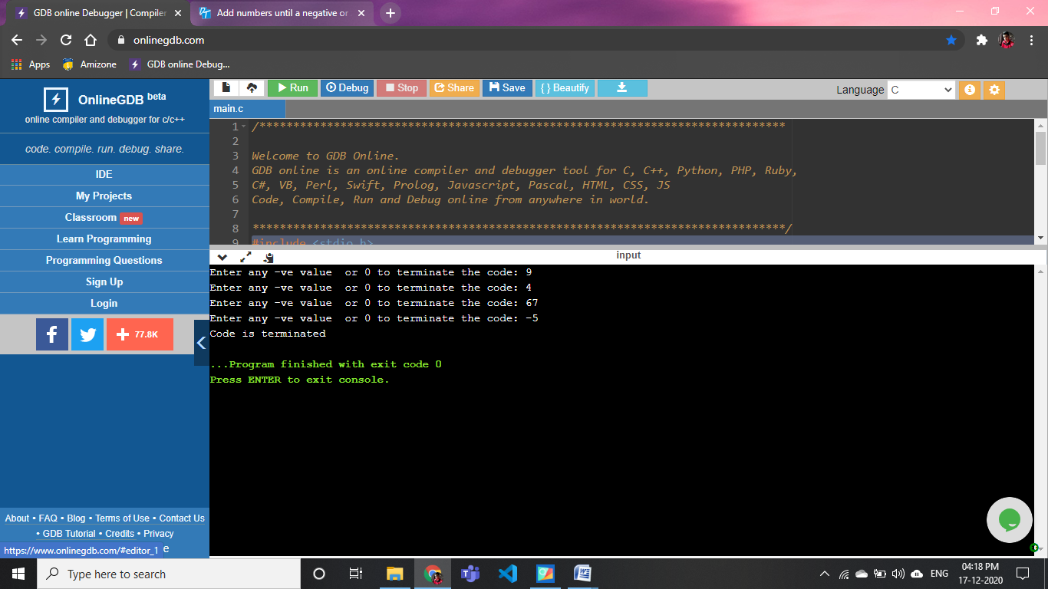

**14).Write a program to print all the odd numbers from 1 to 20 using *continue***

#include <stdio.h>

#include<math.h>

int

main ()

{

int i, c;

printf ("This is code of printing all the odd no. b/w 1-20: ");

for (i = 0; i <= 9; i++)

{

c = 2 * i + 1;

printf ("%d,", c);

continue;

}

return 0;

}

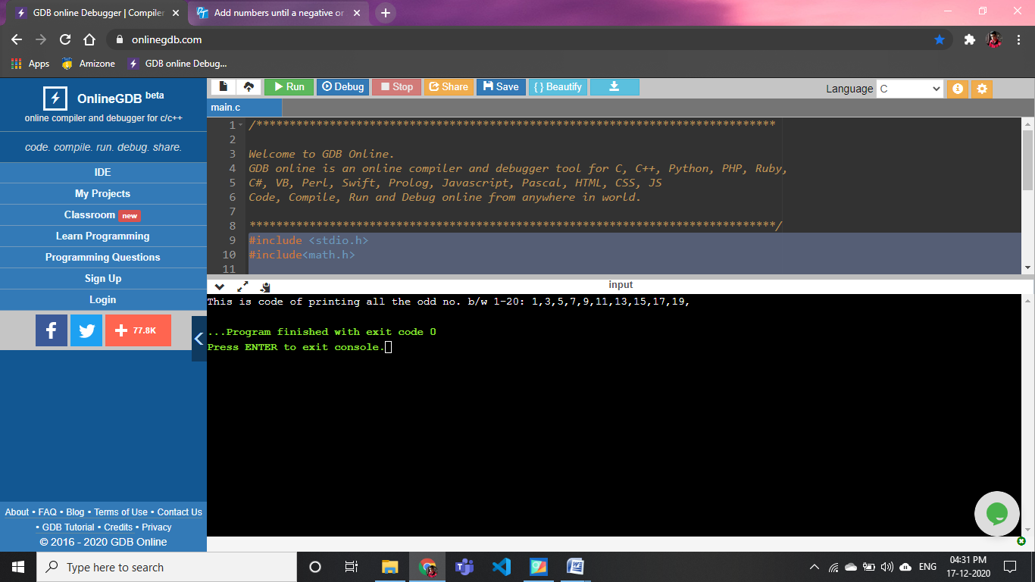

**15).Write a program to find maximum among 2 numbers**

#include <stdio.h>

#include<math.h>

int

main ()

{

int a, b;

printf ("Enter any two values to find maximum on:\n ");

printf("a: ");

scanf("%d",&a);

printf("b: ");

scanf("%d",&b);

if(a>b)

printf("%d is larger",a);

else

printf("%d is larger ",b);

return 0;

}

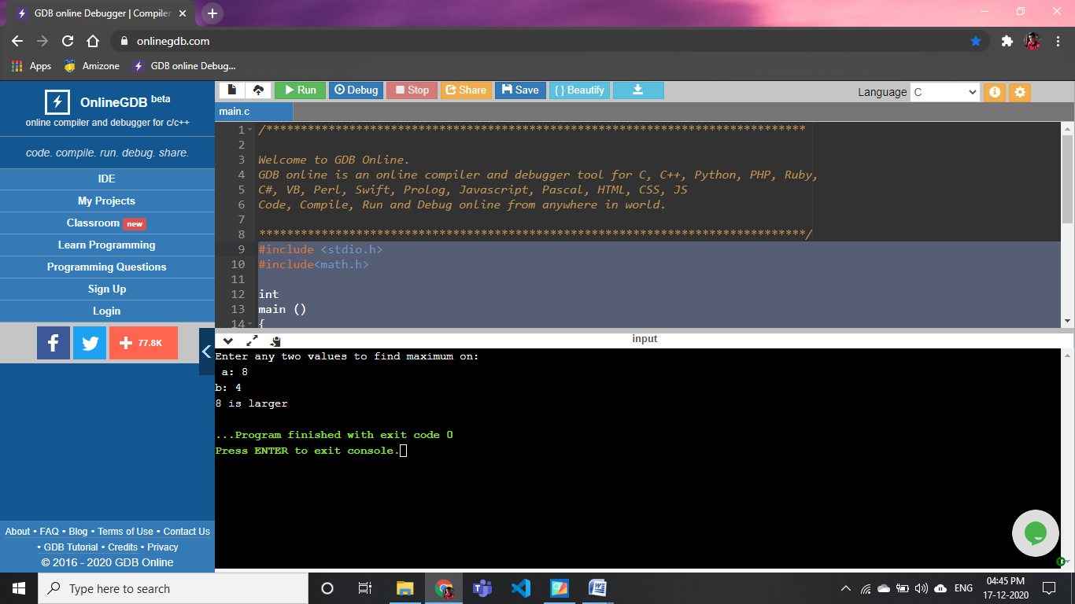

**16).Write a program to find maximum among3 numbers**

include <stdio.h>

#include<math.h>

int main ()

{

int a, b,c;

printf ("Enter any three values to find maximum on:\n ");

printf("a: ");

scanf("%d",&a);

printf("b: ");

scanf("%d",&b);

printf("c: ");

scanf("%d",&c);

if(a>b&&a>c)

printf("%d is larger",a);

else if(b>a&&b>c)

printf("%d is larger ",b);

else

printf("%d is larger",c);

return 0;

}

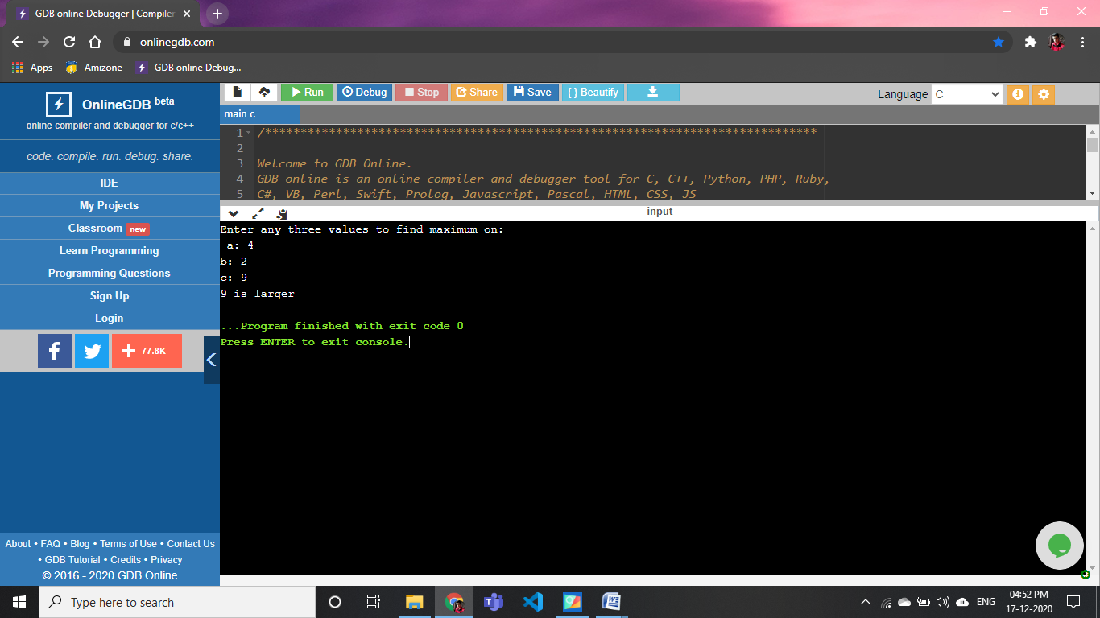

**17).Write a program to check whether a number is negative, positive, or zero**

#include <stdio.h>

#include<math.h>

int main ()

{

int a;

printf ("Enter any values to check whether the no. is +ve ,-ve or 0:\n ");

printf("a: ");

scanf("%d",&a);

if(a>0)

printf("%d is +ve value",a);

else if(a<0)

printf("%d is -ve value ",a);

else

printf("%d is zero",a);

return 0;

}

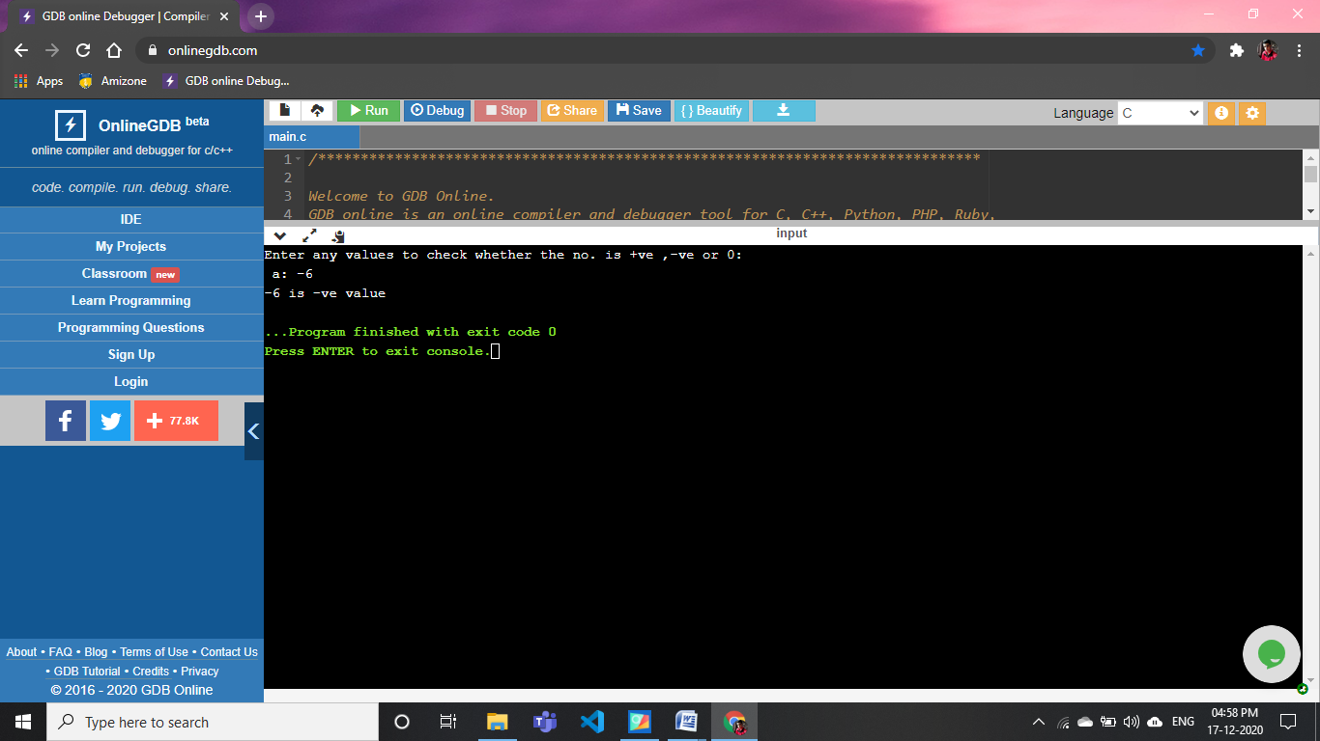

**18).Write a program to check whether a number is even or odd**

#include <stdio.h>

#include<math.h>

int main ()

{

int a;

printf ("Enter any values to check whether the no. is odd or even:\n ");

printf("a: ");

scanf("%d",&a);

if(a%2==0)

printf("%d is even value",a);

else

printf("%d odd value",a);

return 0;

}

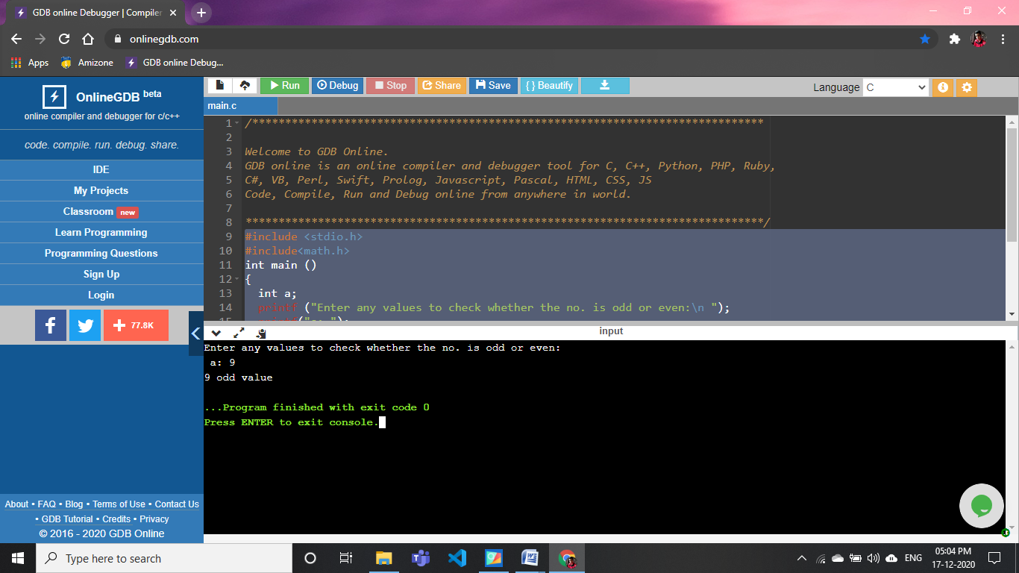

**19).Write a program to input any character and check whether it is alphabet, digit, or special character**

#include <stdio.h>

#include<math.h>

int main ()

{

char i;

printf ("Enter any values to check whether it is alphabet, digit, or special character:\n ");

printf("i: ");

scanf("%c",&i);

if((i>'a'&&i<'z')||(i>'A'&&i<'Z'))

printf("This is alphabet");

else if(i>='0'&&i<='9')

printf( "This is integer value");

else

printf(" is special charecter");

return 0;

}

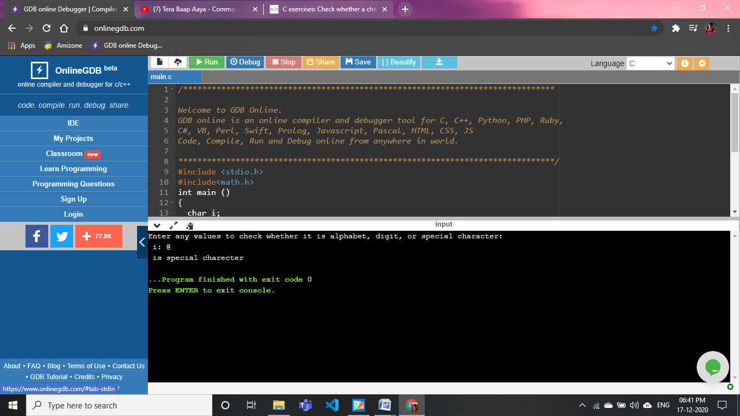

**20).Write a program to find all roots of a quadratic equation**

#include <stdio.h>

#include<math.h>

int

main ()

{

float a, b, c, d, x1, x2;

printf

("Enter coficients a,b,c of any quadratic equation to find its roots: ");

scanf ("%f %f %f", &a, &b, &c);

d = (b * b) - (4 * a * c);

x1 = ((-1*b) + sqrt (d))/2*a;

x2 = ((-1*b) - sqrt (d))/2*a;

printf ("\n x1=%.2f\nx2=%.2f", x1, x2);

return 0;

}

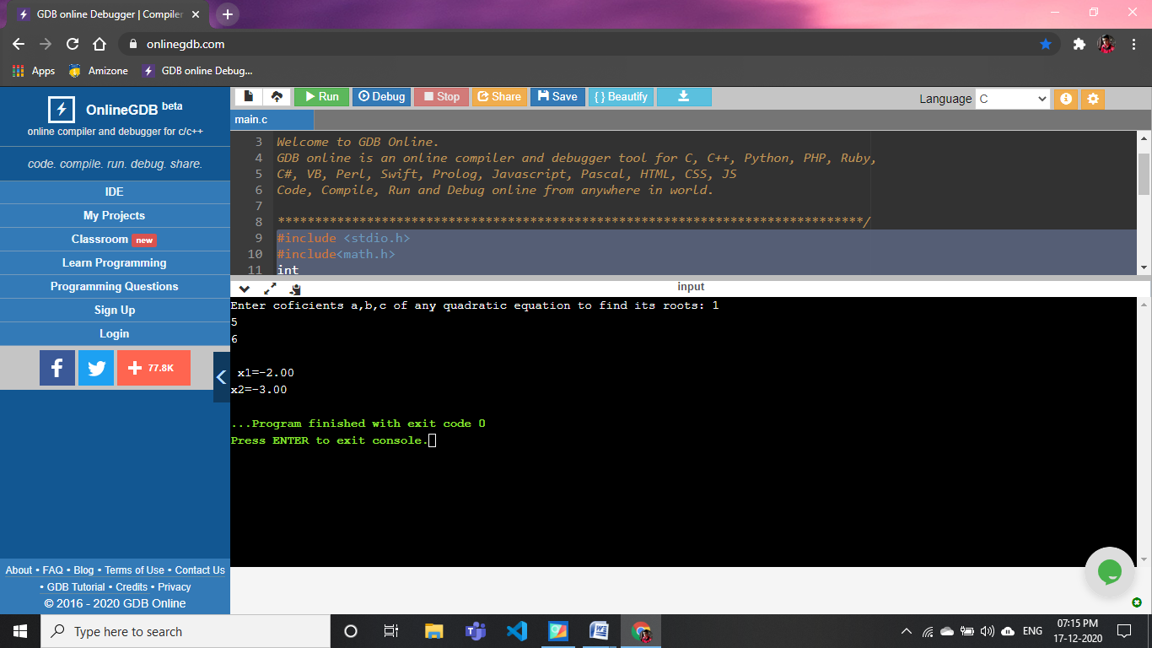

**21).WAP to check whether a number is an Armstrong number**

#include <stdio.h>

#include<math.h>

int main()

{

 int a,b,calc,r;

    calc=0;

    printf("enter any number to be checked:\n");

    scanf("%d",&a);

    b=a;

    while(a>0)

    {

     r=a%10;

     calc=calc+pow(r,3);

     a=a/10;

    }

    if(calc==b)

    printf("it is an armstrong number");

    else

    printf("it is not an armstrong number");

    return 0;

}

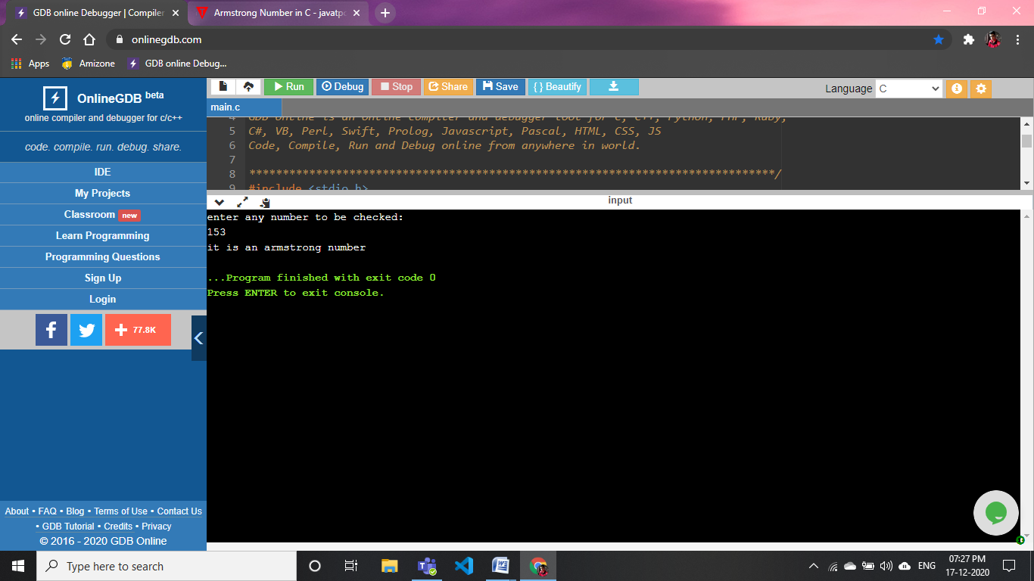

22).WAP to check whether a number is a strong number or not

#include <stdio.h>

#include<math.h>

int main()

{

     int a,b,r,fact,c,i;

    c=0;

    printf("enter any number\n");

    scanf("%d",&a);

    b=a;

    while(a>0)

    {

        r=a%10;

        fact=1;

        if(r)

        {

            for(i=1;i<=r;i++)

                fact=fact*i;

        }

        c+=fact;

        a=a/10;

    }

    if(c==b)

        printf("it is a strong number");

    else

        printf("it is not a strong number");

    return 0;

}

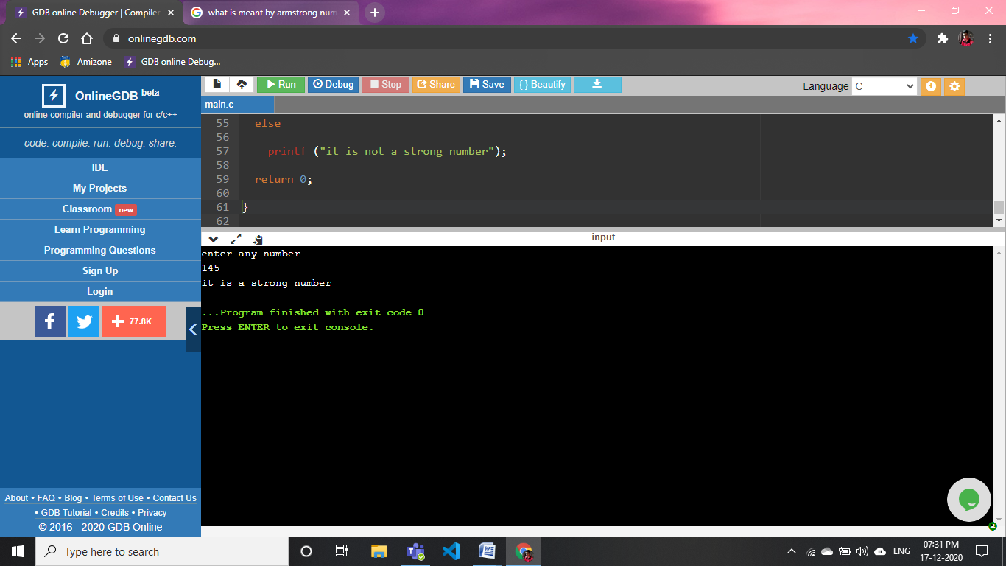

**23).WAP to find the factorial of a number**

#include <stdio.h>

#include<math.h>

int main ()

{

int a;

printf ("PLS enter the +ve value whose factorial u want to find:\n");

scanf ("%d", &a);

int fact = 1;

if (a)

{

for (int i = 1; i <= a; i++)

{

fact *= i;

}

}

printf ("factorial of the given number is: %d\n", fact);

return 0;

}

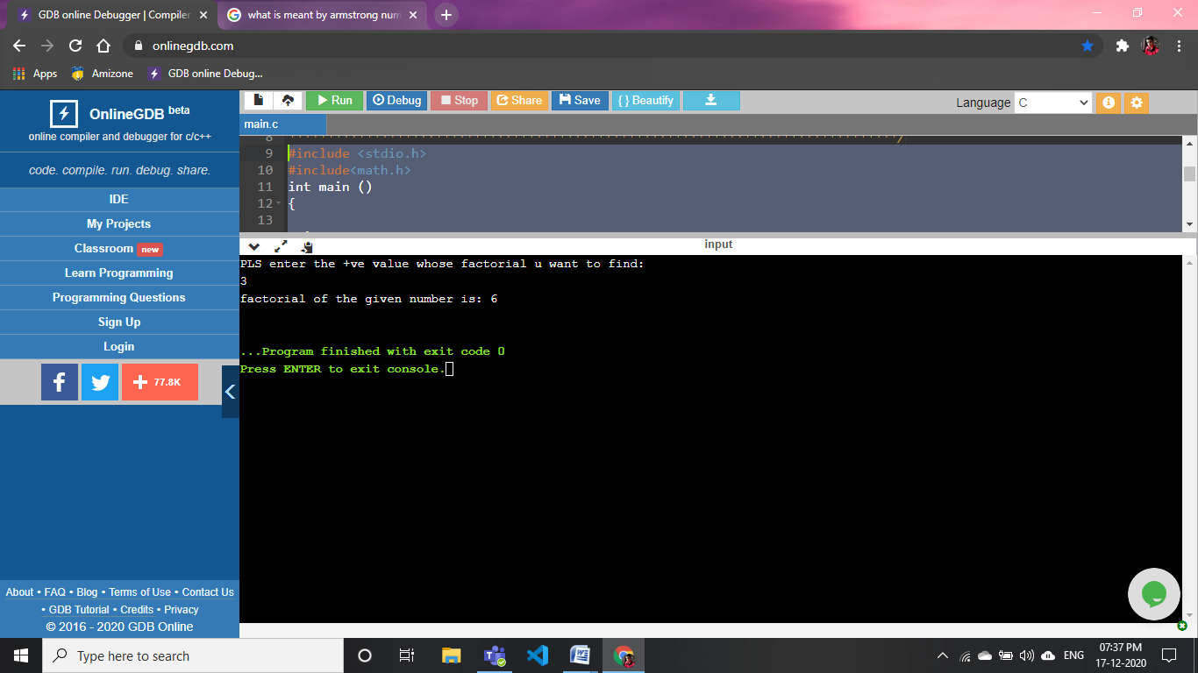

**24)WAP for Fibonacci series**

#include <stdio.h>

#include <stdlib.h>

int main()

{

int sum = 0, n;

int a = 0;

int b = 1;

printf("Enter the nth value: ");

scanf("%d", &n);

printf("Fibonacci series: ");

while(sum <= n)

{

printf("%d ", sum);

a = b;

b = sum;

sum = a + b;

}

return 0;

}

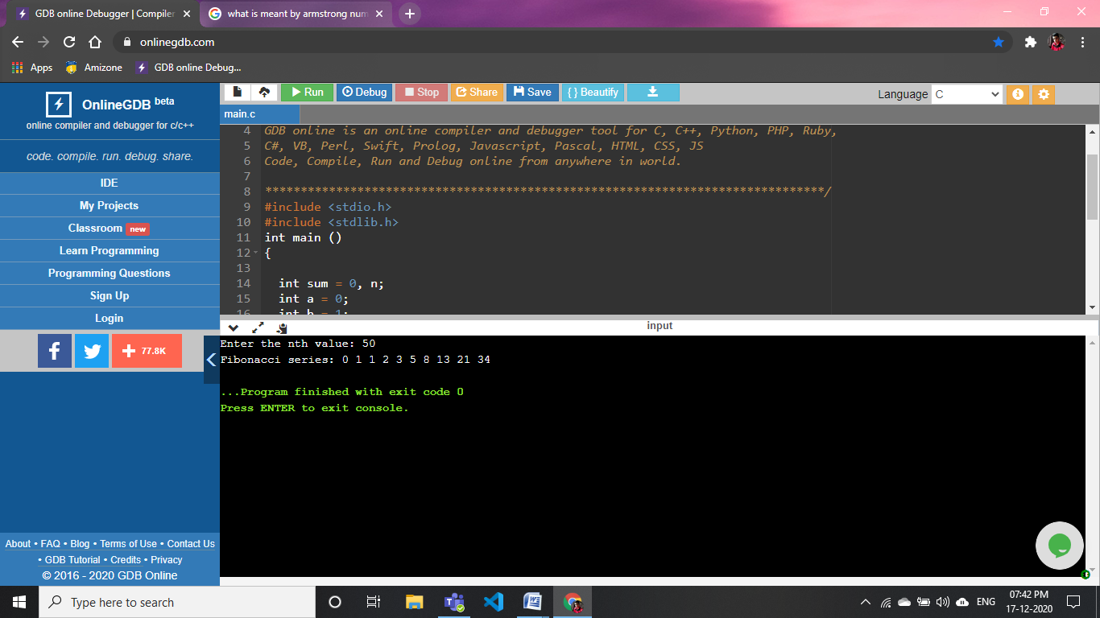

**25).WAP to check whether a year is a leap year or not.**

***#include <stdio.h>***

***int main()***

***{***

***int year;***

***printf("Pls Enter a year to check wheather the year is leap year or not:\n ");***

***scanf("%d", &year);***

***if (year % 400 == 0)***

***{***

***printf("%d is a leap year.", year);***

***}***

***else if (year % 100 == 0)***

***{***

***printf("%d is not a leap year.", year);***

***}***

***else if (year % 4 == 0)***

***{***

***printf("%d is a leap year.", year);***

***}***

***else {***

***printf("%d is not a leap year.", year);***

***}***

***return 0;***

***}***

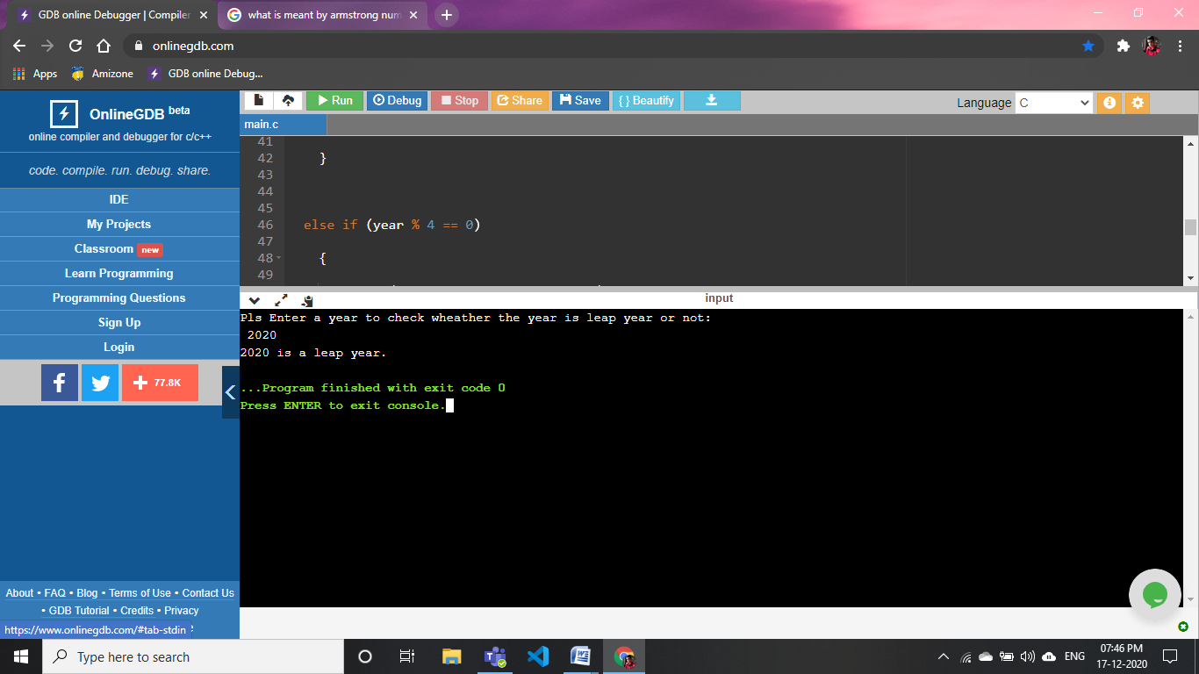

**26).WAP that uses nested for loop in C to put a multiplication table**

***#include <stdio.h>***

***int main()***

***{***

***int a,i,b;***

***printf("Enter the value whose table u want:\n");***

***scanf("%d",&b);***

***for(a=1;a<=b;a++)***

***{***

***printf("Multiplication Table of %d\n",a);***

***for (i = 1; i <= 10; i++)***

***printf("%dX%d=%d\n", a, i, a* i);***

***}***

***return 0;***

***}***

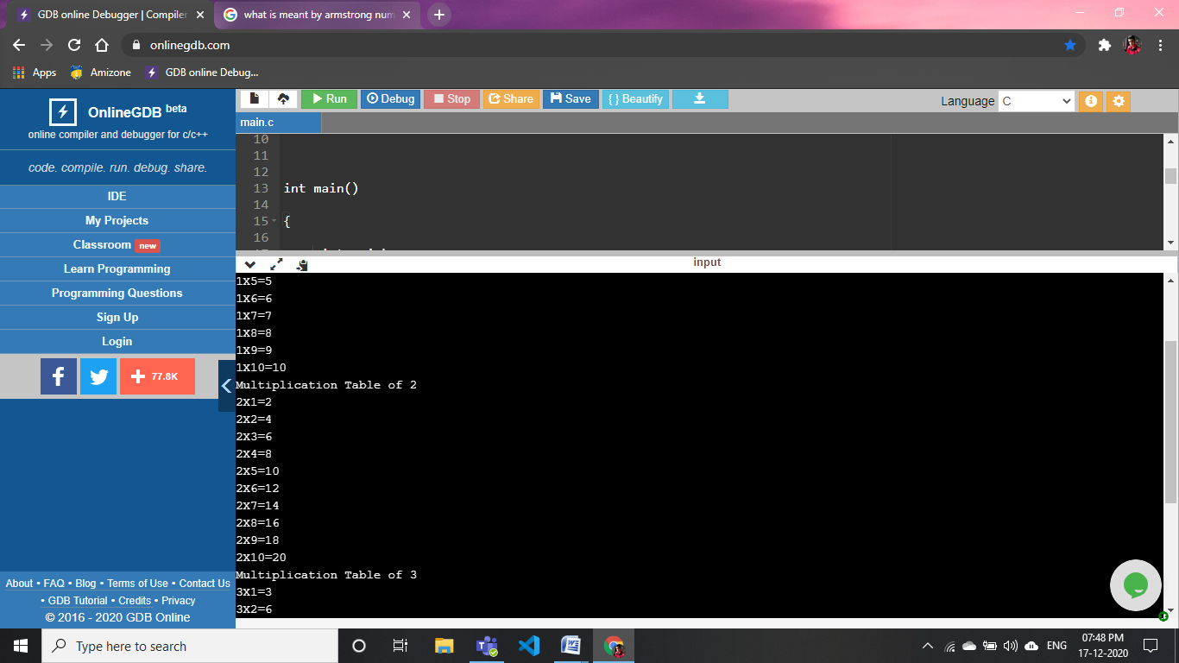

**27).WAP to print a natural number in range**

#include <stdio.h>

int main()

{

  int a,i;

  printf("Enter the no. to print natural no.:\n  ");

  scanf("%d",&a);

  for(i=1;i<=a;i++)

  {

      printf("%d,",i);

  }

    return 0;

}

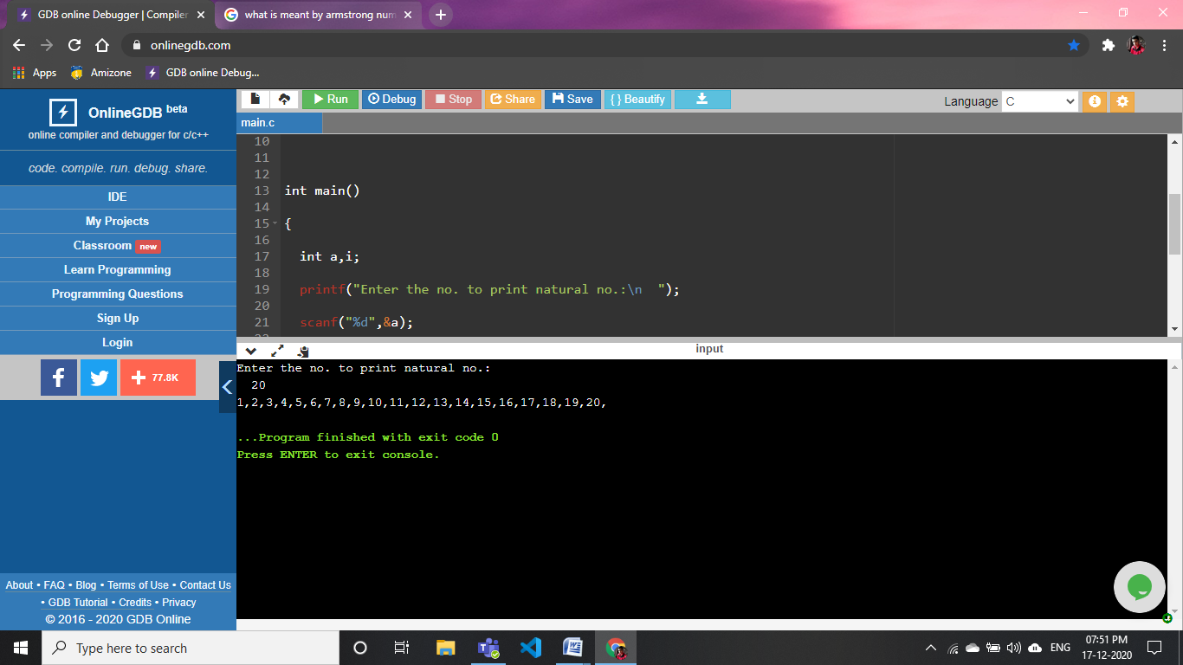

**28).WAP to print natural numbers in reverse in the given range**

**#include <stdio.h>**

**int main()**

**{**

**int a,i;**

**printf("Enter the no. to reverse print natural no.:\n");**

**scanf("%d",&a);**

**for(i=a;i>=1;--i)**

**{**

**printf("%d,",i);**

**}**

**return 0;**

**}**

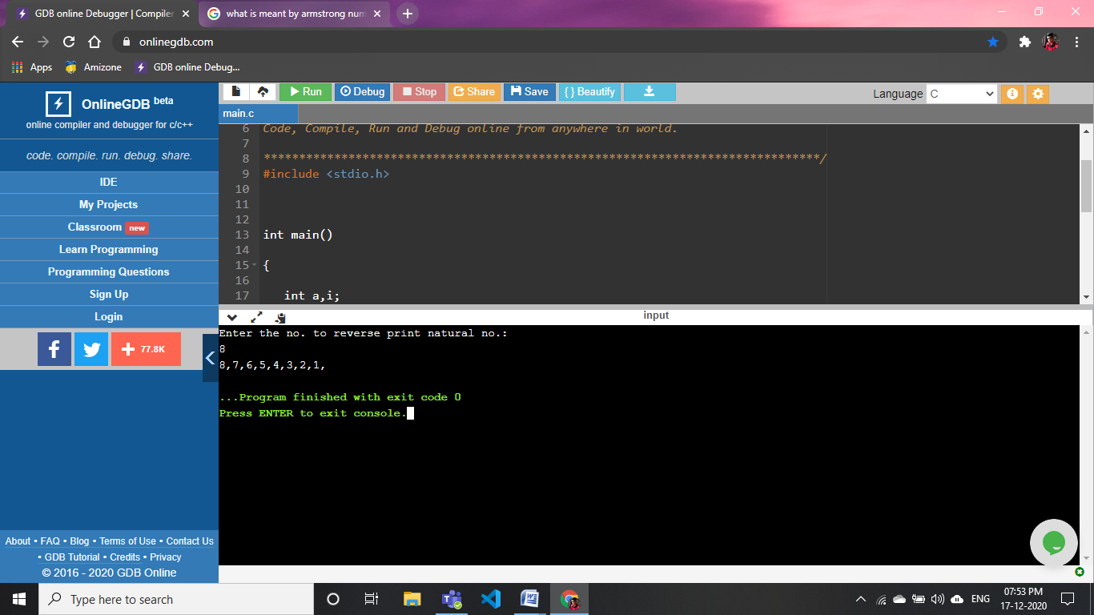

**29).WAP to print alphabets from a-z**

#include <stdio.h>

int

main ()

{

char a;

for (a = 'a'; a <= 'z'; a++)

{

printf ("%c,", a);

}

return 0;

}

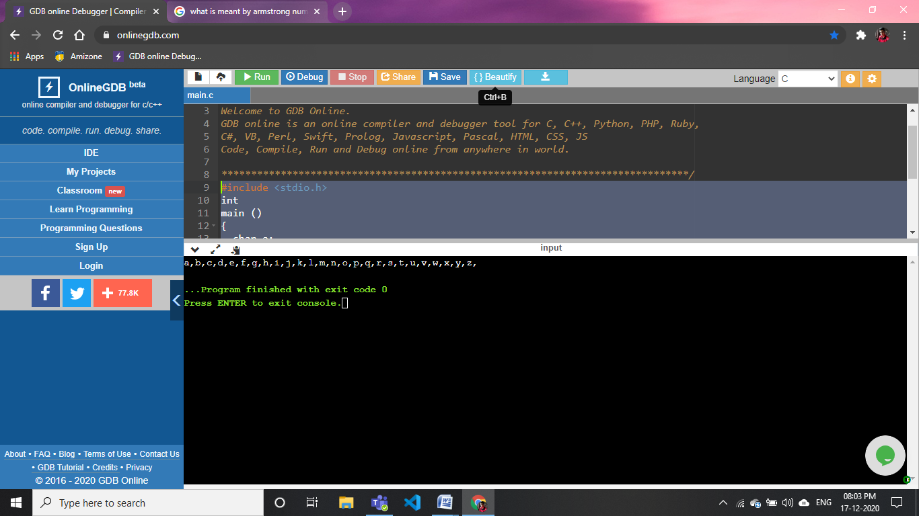

**30).WAP to find the power**

#include <stdio.h>

int main()

{

     int a, b,c;

     c= 1;

    int i;

    printf("Enter base: ");

    scanf("%d", &a);

    printf("Enter exponent: ");

    scanf("%d", &b);

    for(i=1; i<=b; i++)

    {

        c = c * a;

    }

    printf("%d ^ %d = %d", a, b, c);

    return 0;

}

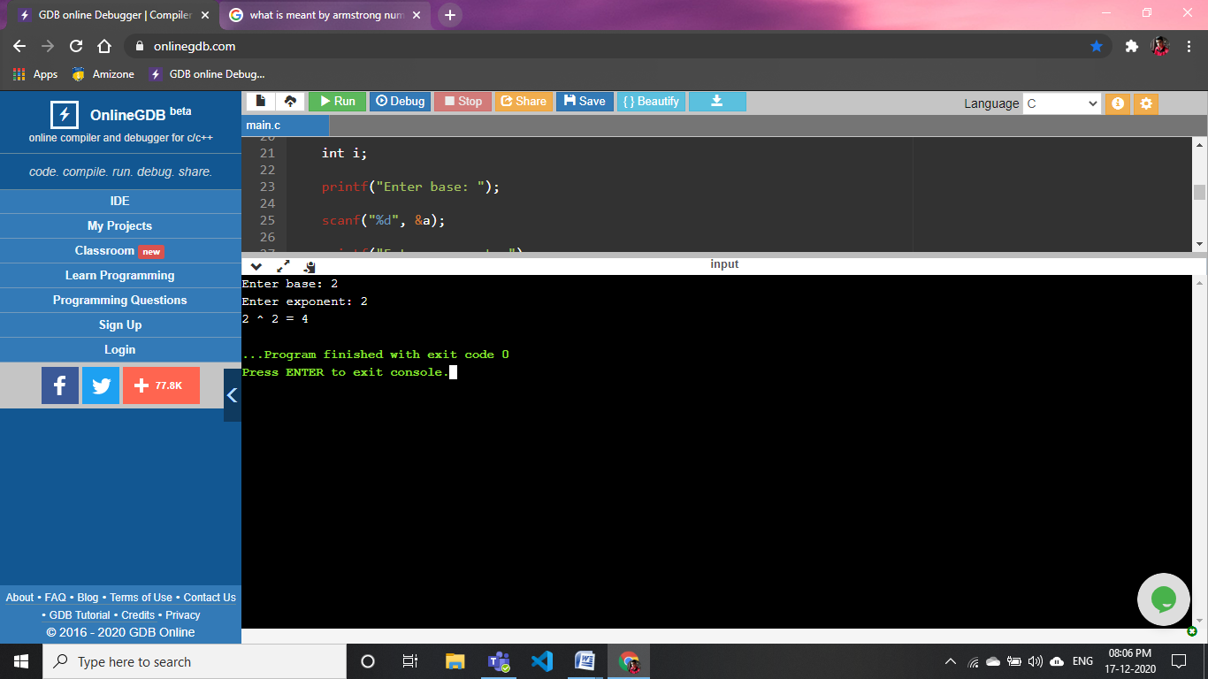

**31).WAP to find the sum of odd numbers from 1 to n**

#include <stdio.h>

int main ()

{

int a, i, sum;

printf ("Enter the last value to get sum of odd no.");

scanf ("%d", &a);

for (i = 1; i <= a; i++)

{

if (i % 2 != 0)

{

sum = sum + i;

}

}

printf ("sum=%d", sum);

return 0;

}

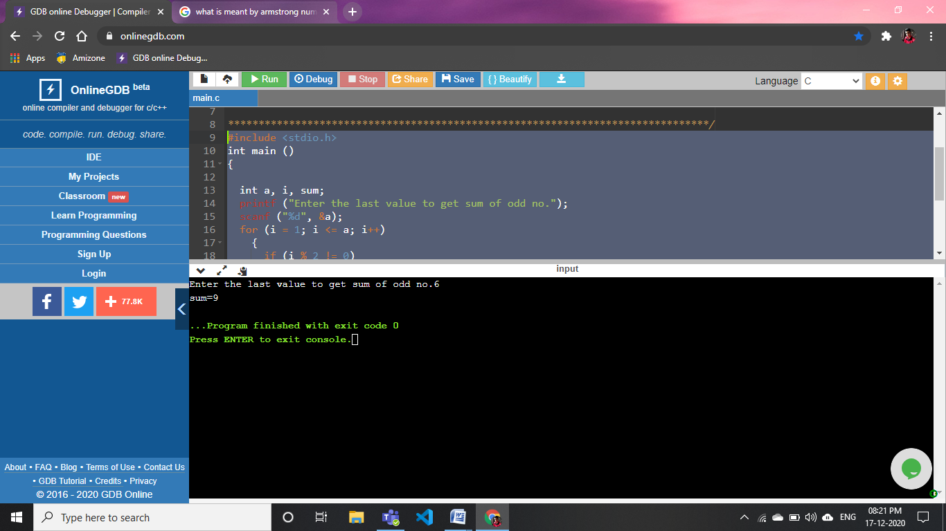

**32).WAP to check whether a number is perfect number or not**

#include<stdio.h>

Int main ()

{

int number, sum = 0, i = 1;

printf ("Please enter a number to check perfect number\n");

scanf ("%d", &number);

while (i < number)

{

if (number % i == 0)

{

sum = sum + i;

}

i++;

}

if (sum == number)

printf ("\nEntered number %d is a perfect number", i);

else

printf ("\nEntered number %d is not a perfect number", i);

return 0;

}

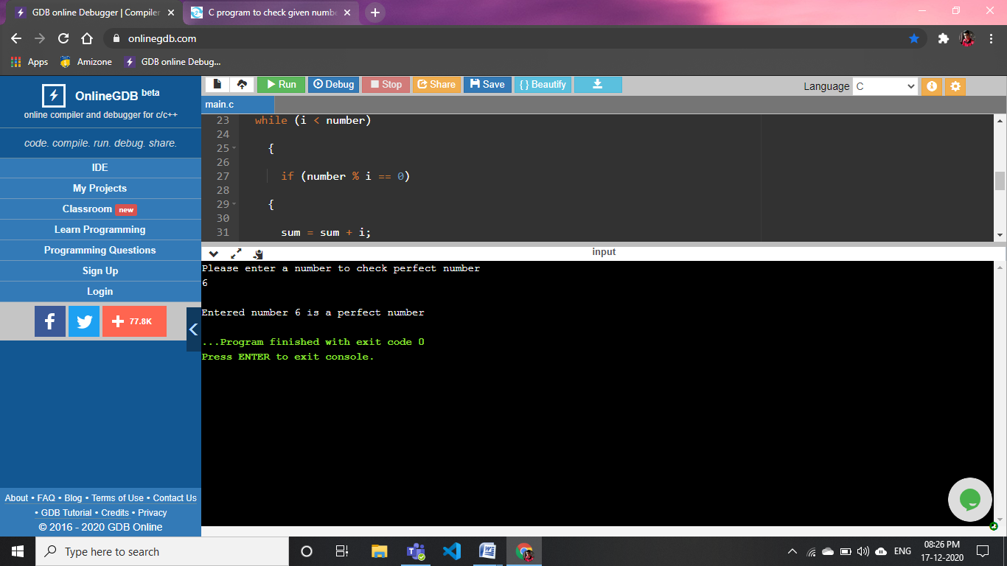

**33). WAP to print the first and last digit of a number, also find the sum**

#include<stdio.h>

int

main ()

{

int n,lastdigit,firstDigit,sum;

printf("Enter some value to print first and last digit \n");

scanf("%d",&n);

lastdigit=n%10;

while(n >= 10)

{

n = n / 10;

}

firstDigit = n;

printf("firstDigit=%d \nlastdigit=%d",firstDigit,lastdigit);

sum=firstDigit+lastdigit;

printf("\nsum=%d",sum);

return 0;

}

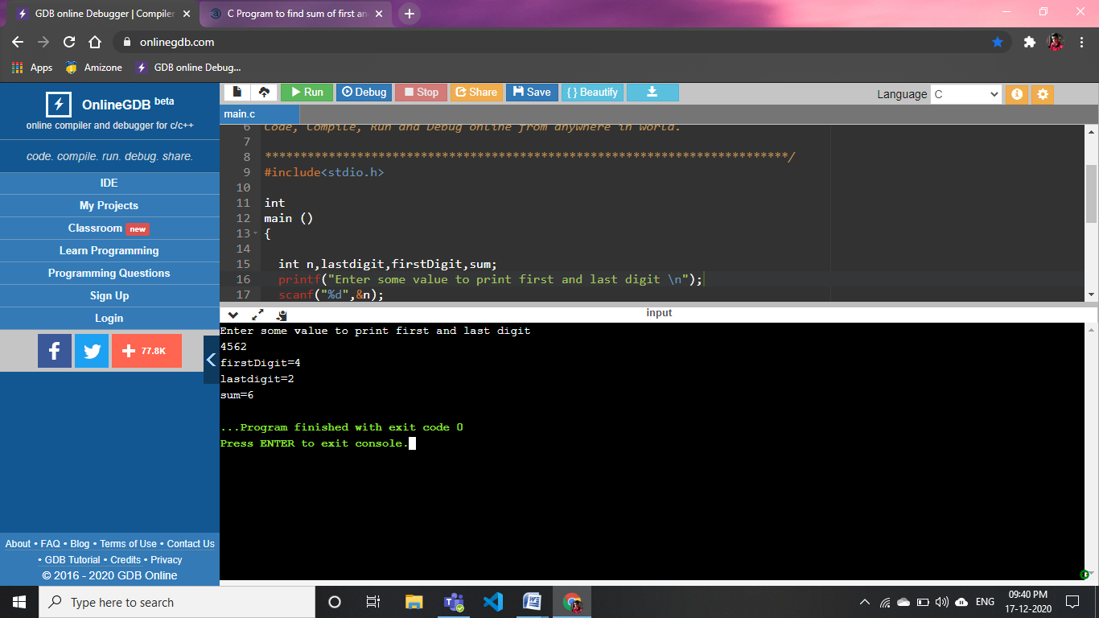

34).WAP to find the sum and product of digits of a **number**

#include <stdio.h>

int

main ()

{

int n;

int d, sum, pro;

printf ("\nEnter an integer number :");

scanf ("%d", &n);

sum = 0;

pro = 1;

while (n > 0)

{

d = n % 10;

sum += d;

pro *= d;

n = n / 10;

}

printf ("\nSUM of all Digits is : %d", sum);

printf ("\nPRODUCT of all digits: %d", pro);

return 0;

}

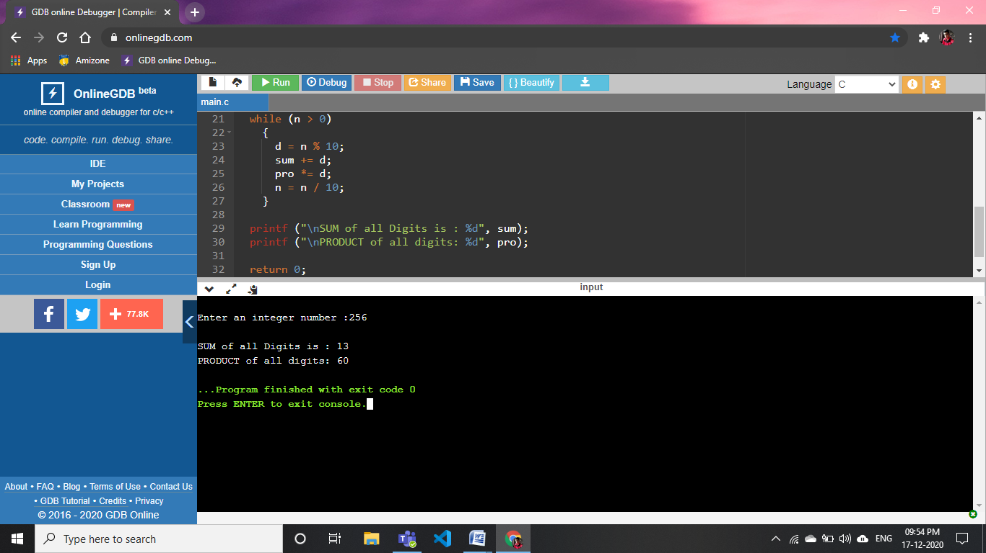

**35).WAP to convert binary number to decimal**

#include <stdio.h>

#include<math.h>

int

main ()

{

int a,i=0,l,sum=0;

printf("Enter binary value to convert into decimal:\n");

scanf("%d",&a);

while(a!=0)

{

l=a%10;

sum=sum+l*pow(2,i);

i++;

a=a/10;

}

printf("decimal=%d",sum);

return 0;

}

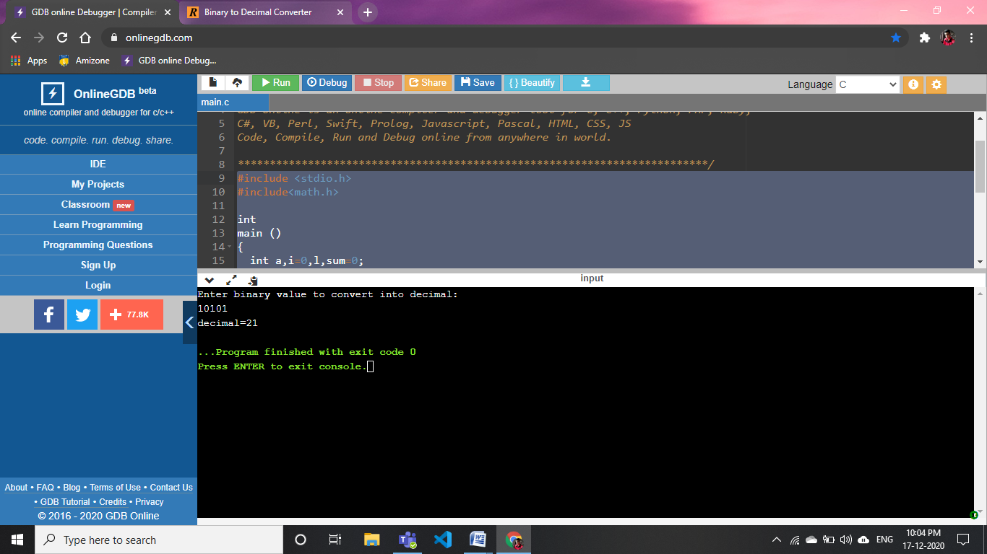

**36).WAP to print a table of number 2 using do-while loop.**

#include <stdio.h>

#include<math.h>

int

main ()

{

int i = 1;

printf ("This is code of print table of 2 using do while loop:\n");

do

{

printf ("2x%d=%d\n", i, 2 * i);

i++;

}

while (i <= 10);

return 0;

}

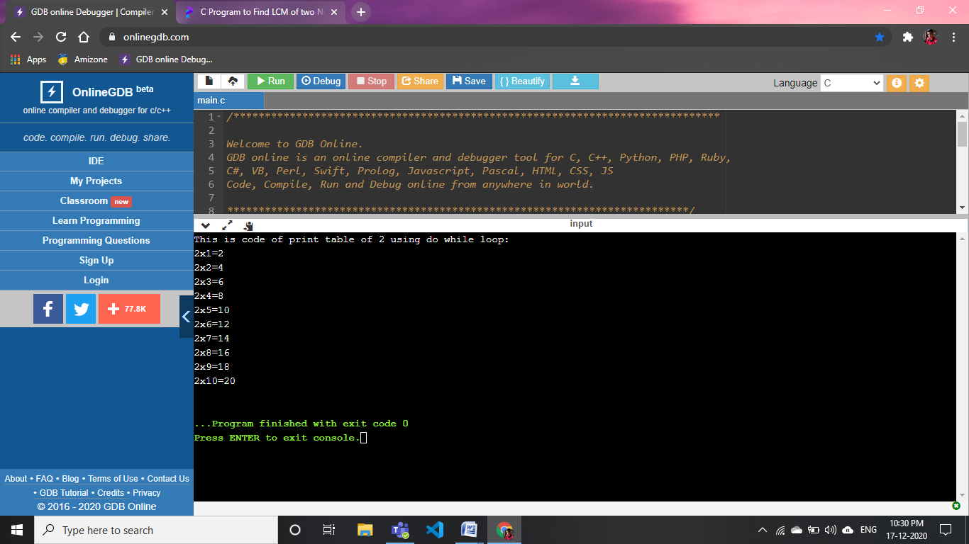

37).WAP to read and print the array elements

#include <stdio.h>

int

main ()

{

int i, n;

printf (" Pls Enter size of array:- ");

scanf ("%d", &n);

int a[n];

printf

("Now u have to enter %d elements in the array to print element in array: \n",

n);

for (i = 0; i < n; i++)

{

scanf ("%d", &a[i]);

}

printf ("\nElements in array are: ");

for (i = 0; i < n; i++)

{

printf ("%d ", a[i]);

}

return 0;

}

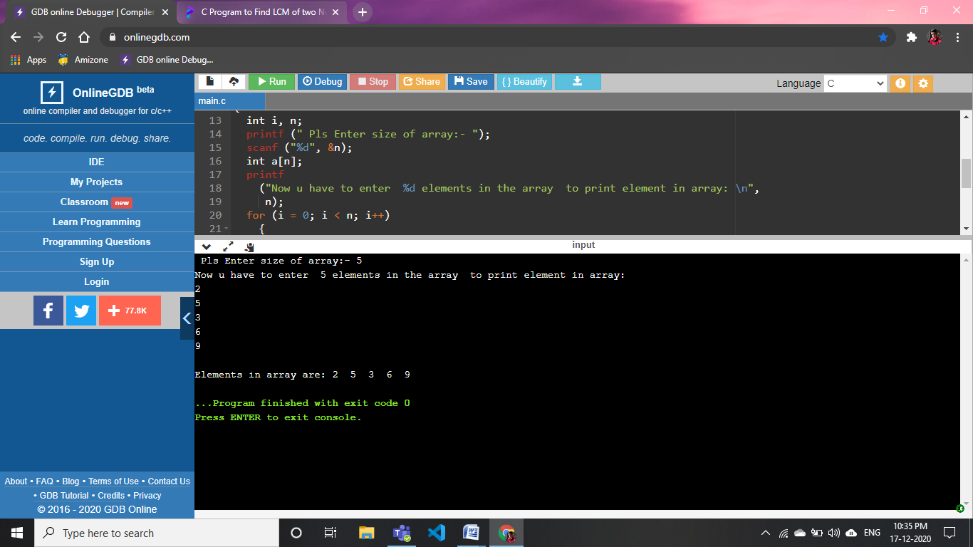

**38).WAP to find the sum of all the array elements**

#include <stdio.h>

int

main ()

{

int a[10];

int i, n, sum = 0;

printf ("Pls Enter no. of the elements to be stored in the array :\n");

scanf ("%d", &n);

printf ("Enter %d elements in the array :\n", n);

for (i = 0; i < n; i++)

{

printf ("element No. %d is: ", i);

scanf ("%d", &a[i]);

}

for (i = 0; i < n; i++)

{

sum += a[i];

}

printf ("Sum of all elements stored in the array is : %d\n\n", sum);

return 0;

}

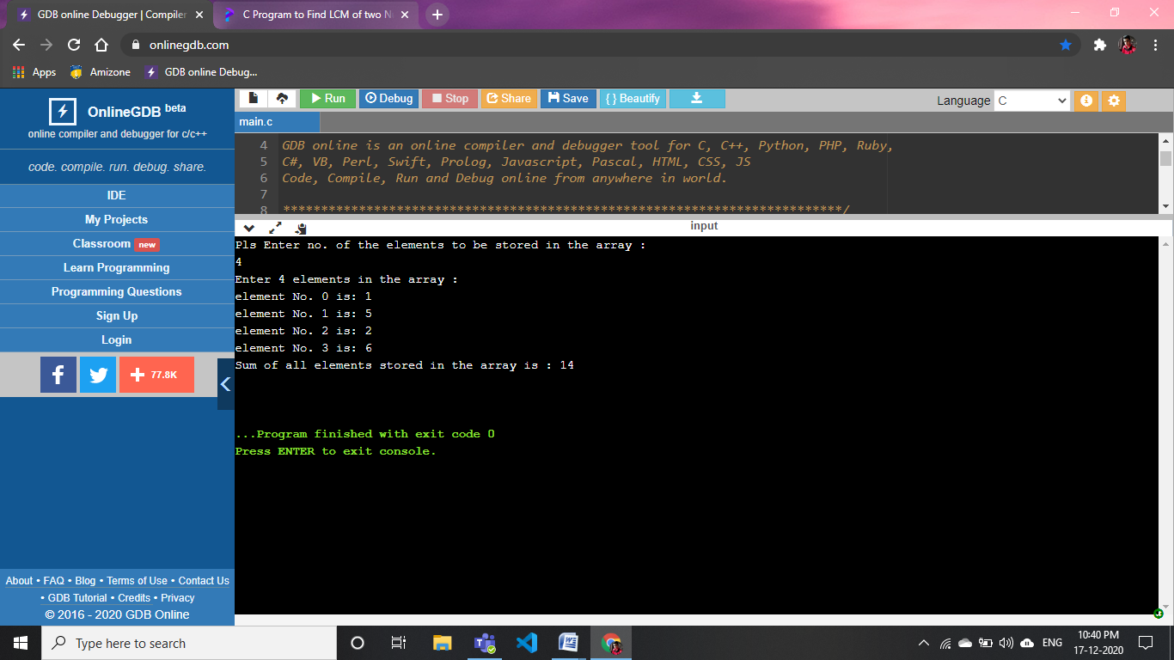

**39).WAP to find the largest element in the array**

#include <stdio.h>

int main()

{

int i, size;

printf("Enter size of your array:\n");

scanf("%d",&size);

int array[size];

printf("Pls enter %d Element to find largest one.",size);

for(i=0;i<size;i++)

{

scanf("%d",&array[i]);

}

// largest=array[0];

for(i=1;i<size;i++)

{

if(array[0]<array[i])

array[0]=array[i];

}

printf("largest= %d",array[0]);

return 0;

}

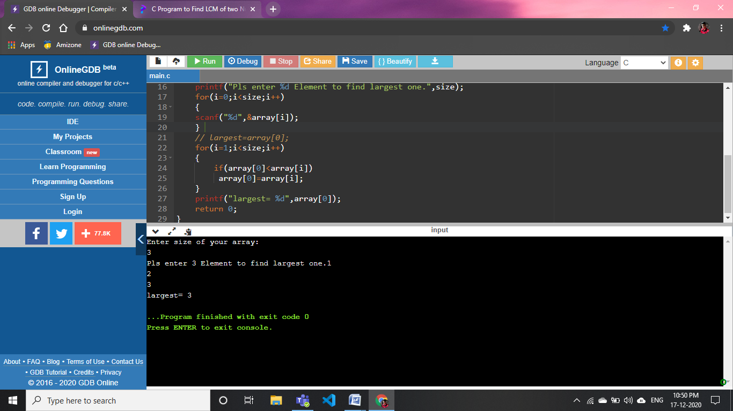

**40).WAP to insert all the elements of one array into another**

#include <stdio.h>

int main()

{

int i, size;

printf("Enter size of your array:\n");

scanf("%d",&size);

int array[size];

int a[size];

printf("Pls enter %d Element to find largest one.\n",size);

for(i=0;i<size;i++)

{

scanf("%d",&array[i]);

}

for(i=0;i<size;i++)

{

a[i]=array[i];

}

printf("elements in first array\n");

for(i=0;i<size;i++)

{

printf("%d ",array[i]);

}

printf("\nelements in second array\n");

for(i=0;i<size;i++)

{

printf("%d ",a[i]);

}

return 0;

}

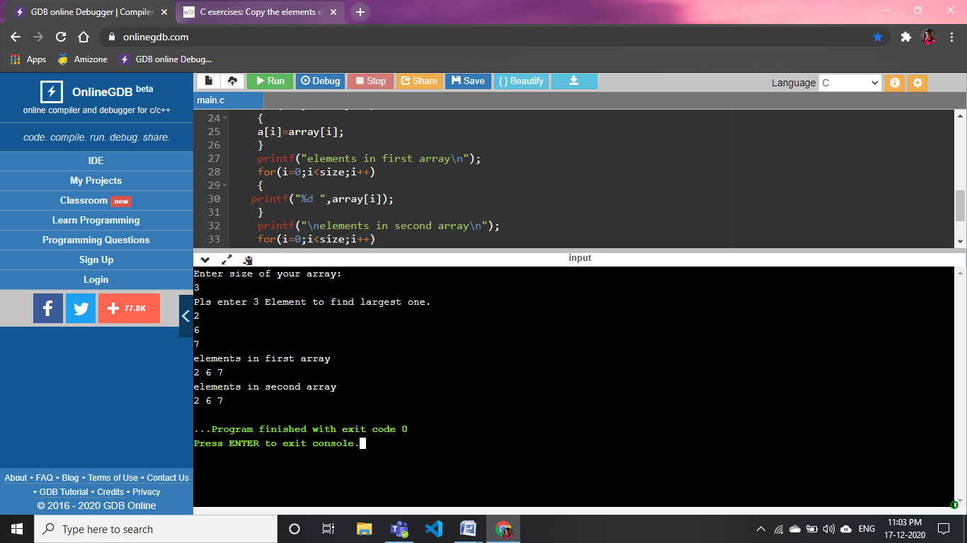

**41).WAP to print negative numbers in array**

#include <stdio.h>

int main()

{

int i, size;

printf("Enter size of your array:\n");

scanf("%d",&size);

int array[size];

printf("Pls enter %d Element to find largest one.\n",size);

for(i=0;i<size;i++)

{

scanf("%d",&array[i]);

}

for(i=0;i<size;i++)

{

printf("%d,",array[i]);

}

return 0;

}

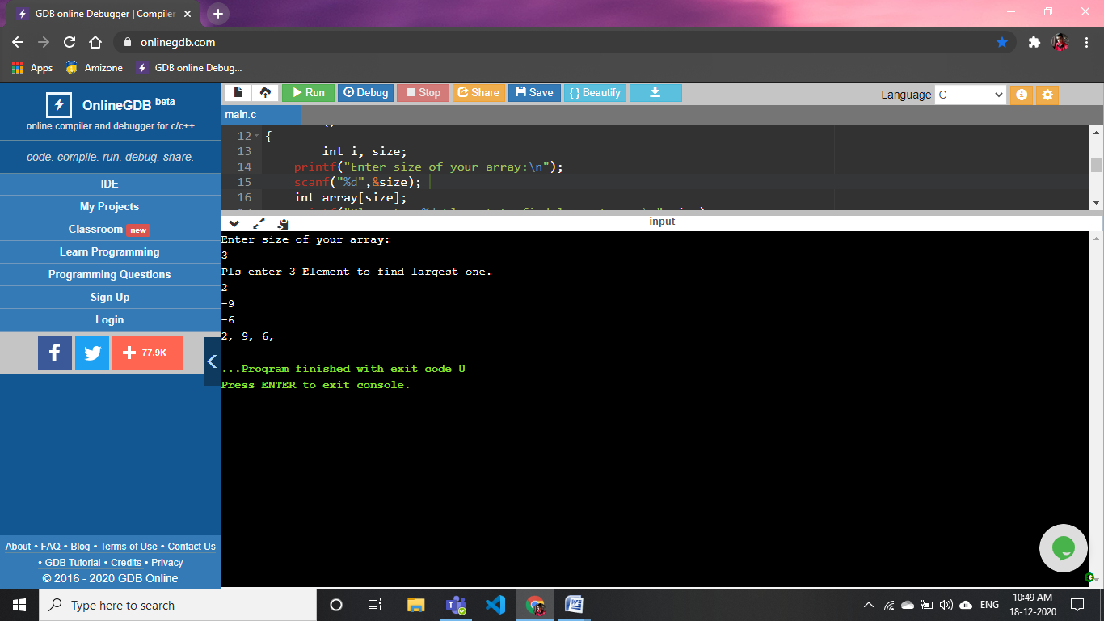

**42).WAP to print array in reverse**

#include <stdio.h>

int main ()

{

int i, a, size;

printf ("Pls Enter size of your array: \n");

scanf ("%d", &size);

int array[size];

printf ("Pls enter %d element to check largest among all array\n", size);

for (i = 0; i < size; i++)

{

scanf ("%d", &array[i]);

}

printf("The reverse of given array is:");

for (i=size-1;i >=0;i--)

{

printf ("%d,",array[i]);

}

return 0;

}

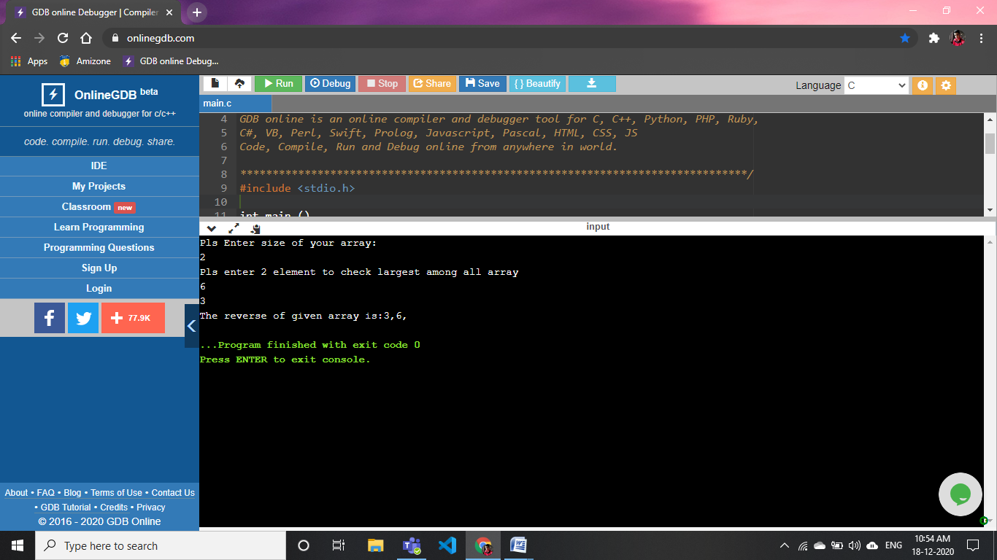

**43).WAP to add two matrix**

#include <stdio.h>

int

main ()

{

int r, c, a[100][100], b[100][100], sum[100][100], i, j;

printf ("Enter the number of rows (between 1 and 100): ");

scanf ("%d", &r);

printf ("Enter the number of columns (between 1 and 100): ");

scanf ("%d", &c);

printf ("\nEnter elements of 1st matrix:\n");

for (i = 0; i < r; ++i)

for (j = 0; j < c; ++j)

{

printf ("Enter element a%d%d: ", i + 1, j + 1);

scanf ("%d", &a[i][j]);

}

printf ("Enter elements of 2nd matrix:\n");

for (i = 0; i < r; ++i)

for (j = 0; j < c; ++j)

{

printf ("Enter element a%d%d: ", i + 1, j + 1);

scanf ("%d", &b[i][j]);

}

for (i = 0; i < r; ++i)

for (j = 0; j < c; ++j)

{

sum[i][j] = a[i][j] + b[i][j];

}

printf ("\nSum of two matrices: \n");

for (i = 0; i < r; ++i)

for (j = 0; j < c; ++j)

{

printf ("%d ", sum[i][j]);

if (j == c - 1)

{

printf ("\n\n");

}

}

return 0;

}

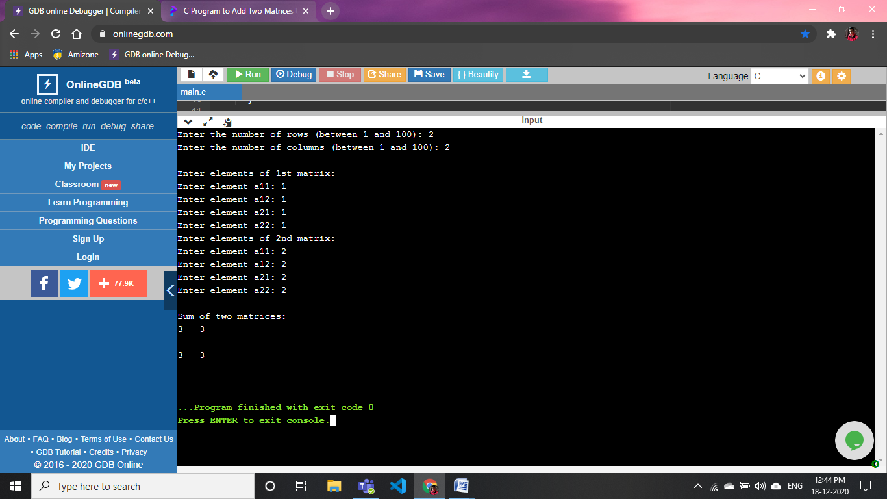

44).WAP to perform matirx multiplication using 2D arrays

#include <stdio.h>

#include<math.h>

int

main ()

{

int r, c, a[100][100], b[100][100], pro[100][100], i, j;

printf ("Enter the number of rows (between 1 and 100): ");

scanf ("%d", &r);

printf ("Enter the number of columns (between 1 and 100): ");

scanf ("%d", &c);

printf ("\nEnter elements of 1st matrix:\n");

for (i = 0; i < r; ++i)

for (j = 0; j < c; ++j)

{

printf ("Enter element a%d%d: ", i + 1, j + 1);

scanf ("%d", &a[i][j]);

}

printf ("Enter elements of 2nd matrix:\n");

for (i = 0; i < r; ++i)

for (j = 0; j < c; ++j)

{

printf ("Enter element a%d%d: ", i + 1, j + 1);

scanf ("%d", &b[i][j]);

}

for (i = 0; i < r; ++i)

for (j = 0; j < c; ++j)

{

pro[i][j] = a[i][j] * b[i][j];

}

printf ("\nproduct of two matrices: \n");

for (i = 0; i < r; ++i)

for (j = 0; j < c; ++j)

{

printf ("%d ", pro[i][j]);

if (j == c - 1)

{

printf ("\n\n");

}

}

return 0;

}

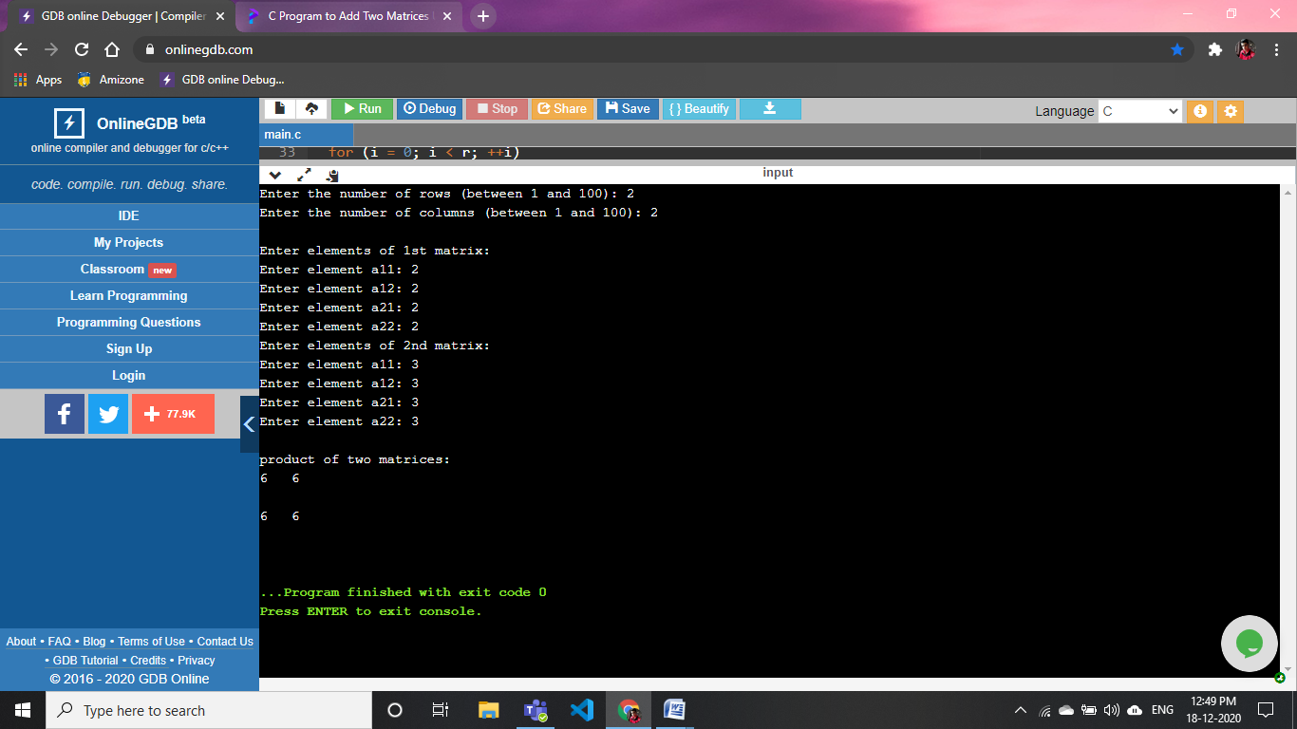

**45).WAP to check whether a given matrix is sparse matrix or not**

#include <stdio.h>

Int main ()

{

int matrix[10][10];

int i, j, m, n;

int sparse_counter = 0;

printf ("Enter the order of the matix \n");

scanf ("%d %d", &m, &n);

printf ("Enter the elements of the matix \n");

for (i = 0; i < m; ++i)

{

for (j = 0; j < n; ++j)

{

scanf ("%d", &matrix[i][j]);

if (matrix[i][j] == 0)

{

++sparse_counter;

}

}

}

if (sparse_counter > ((m * n) / 2))

{

printf ("The given matrix is Sparse Matrix !!! \n");

}

else

printf ("The given matrix is not a Sparse Matrix \n");

printf ("There are %d number of Zeros.", sparse_counter);

return 0;

}

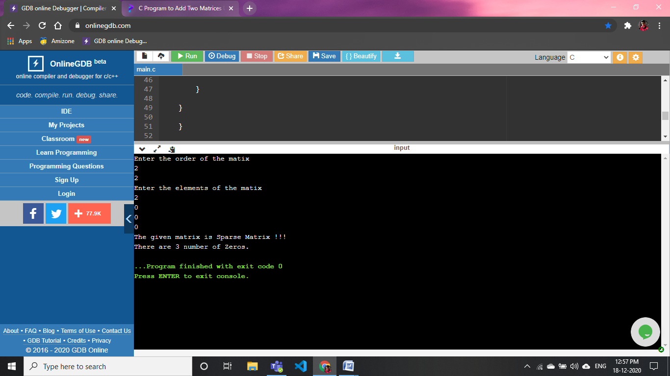

**46).Programs using functions:**

* **to find the cube of any number**

#include <stdio.h>

#include<math.h>

int cube (int);

int main()

{

     int a, result;

    printf ("Pls Enter Any value to get cube:\n");

  scanf ("%d", &a);

  result = cube (a);

 printf ("The cube of Given no. is %d", result);

   return 0;

}

int

cube (int a)

{

  int b;

  b = a * a * a;

  return b;

}

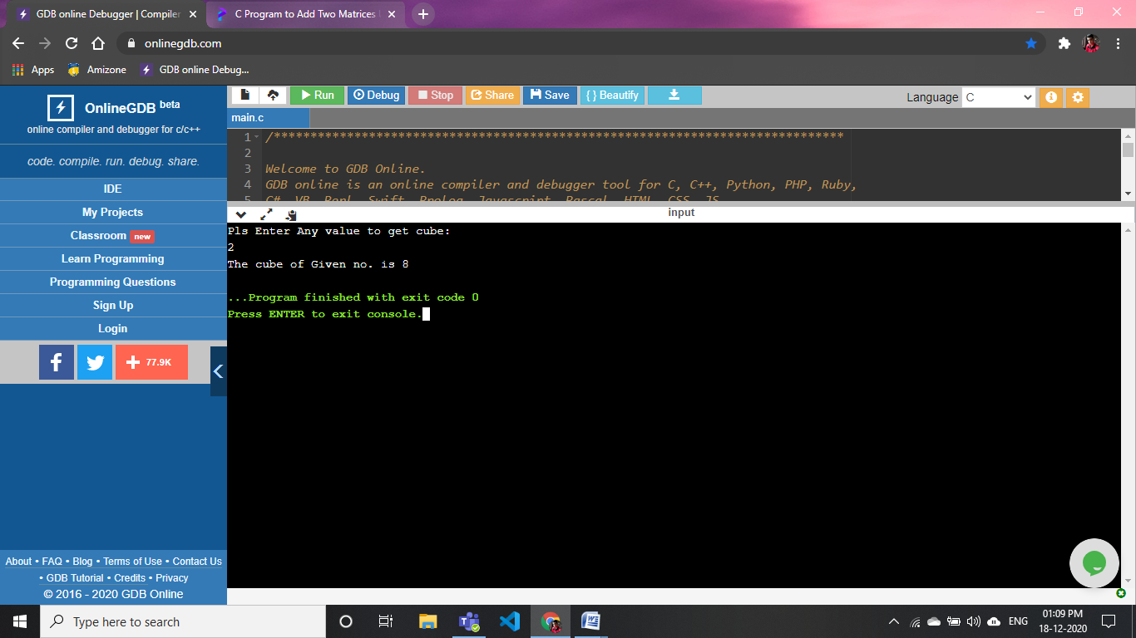

**: to find diameter, circumference and area of circle**

#include <stdio.h>

#include<math.h>

double diameter(double);

double area(double);

double circumference(double);

int main()

{

    float a,b,c,d,dresult;

    printf("Pls Enter radius  to find area , diameter,circumference:\n");

    scanf("%f",&a);

    b=diameter(a);

    c=area(a);

    d=circumference(a);

    printf("The diameter is=%.2f\n",b);

    printf("The area is=%.2f\n",c);

    printf("The circumference is=%.2f\n",d);

    return 0;

}

double diameter(double b)

{

    int c;

    c=b*2;

    return c;

}

double area(double b)

{

    float c;

    c=3.14*b*b;

    return c;

}

double circumference(double b)

{

    float c;

    c=2*3.14*b;

    return c;

}

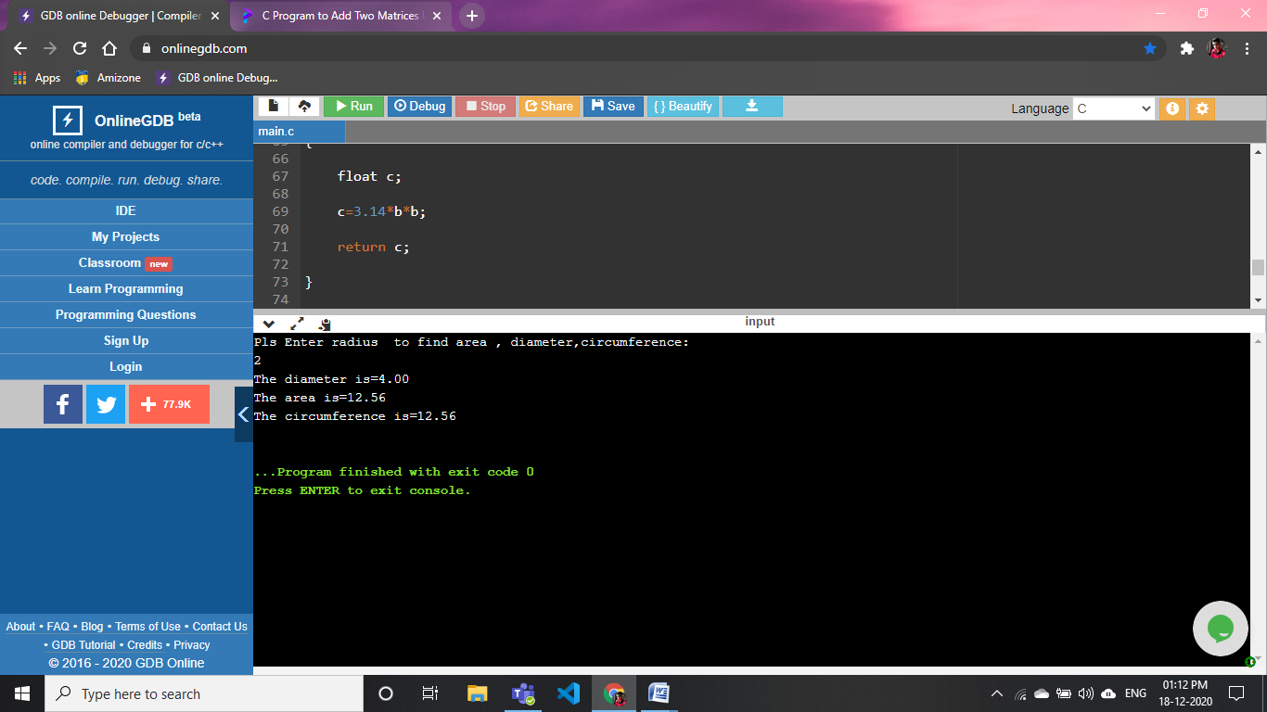

***: to find maximum and minimum between two numbers***

#include <stdio.h>

#include<math.h>

int max (int, int);

int min (int, int);

int

main ()

{

  int a, b, x, y;

  printf ("Enter integer values to find maximum or minimum\n ");

  printf ("Enter first integer:\n");

  scanf ("%d", &a);

  printf ("Enter second integer:\n");

  scanf ("%d", &b);

  if(a>b)

  {

     x= max(a,b);

     y=min(a,b);

      printf(" maximum=%d",x);

      printf("minimum=%d",y);

  }

  else if(b>a)

  {

      x=max(a,b);

      y=min(a,b);

      printf("maximum=%d\n",y);

      printf("minimum=%d\n",x);

  }

  return 0;

}

int

max (int a, int b)

{

   return a;

}

int min(int a,int b)

{

    return b;

}

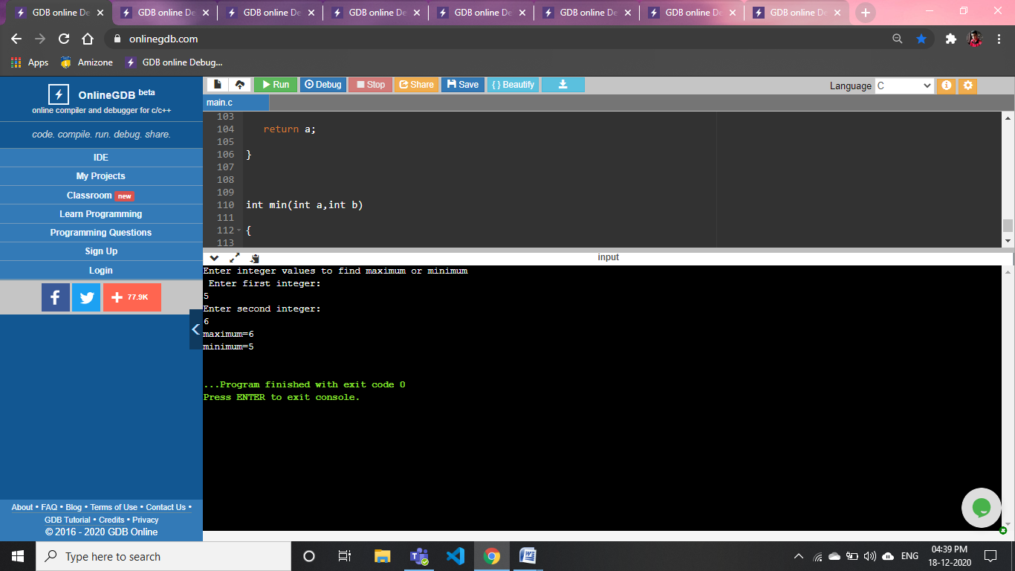

:**to check whether a number is even or odd**

#include <stdio.h>

#include<math.h>

int even(int);

int odd(int);

int main()

{

    int a,x,y;

    printf("Enter ineger value to check it is even or odd:\n ");

    scanf("%d",&a);

    if(a%2==0)

    {

    x=even(a);

    printf("%d is even no.",x);

    }

    else

    {

        y=odd(a);

    printf("%d is odd no",y);

    }

    return 0;

}

int even(int a)

{

return a;

}

int odd(int a)

{

    return a;

}

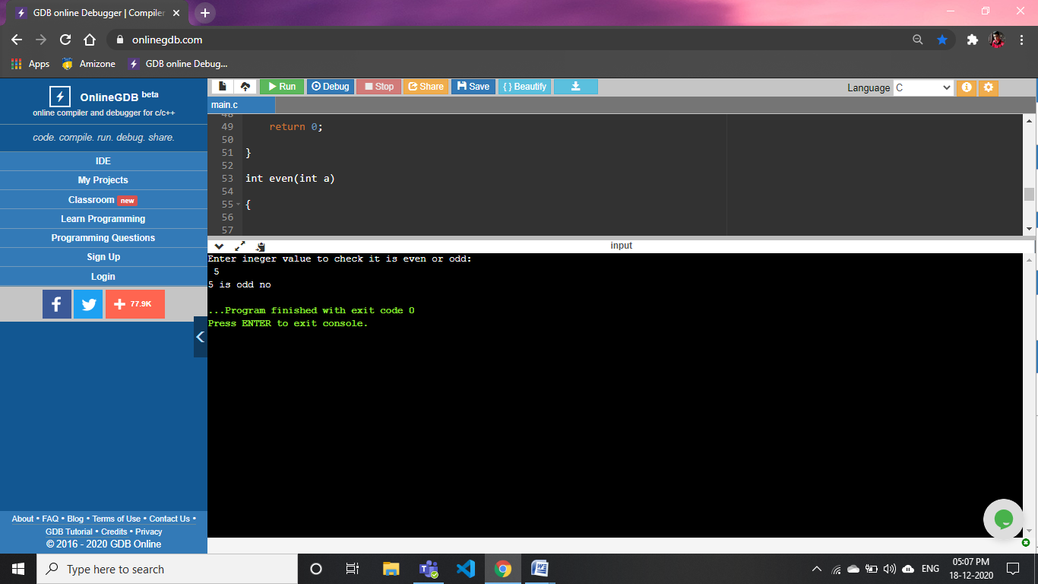

**: to check whether the number is prime, armstrong or perfect number**

#include <stdio.h>

#include <math.h>

int isPrime(int num);

int isArmstrong(int num);

int isPerfect(int num);

int main()

{

int num;

printf("Enter any number: ");

scanf("%d", &num);

if(isPrime(num))

{

printf("%d is Prime number.\n", num);

}

else

{

printf("%d is not Prime number.\n", num);

}

if(isArmstrong(num))

{

printf("%d is Armstrong number.\n", num);

}

else

{

printf("%d is not Armstrong number.\n", num);

}

if(isPerfect(num))

{

printf("%d is Perfect number.\n", num);

}

else

{

printf("%d is not Perfect number.\n", num);

}

return 0;

}

int isPrime(int num)

{

int i;

for(i=2; i<=num/2; i++)

{

if(num%i == 0)

{

return 0;

}

}

return 1;

}

int isArmstrong(int num)

{

int lastDigit, sum, originalNum, digits;

sum = 0;

originalNum = num;

digits = (int) log10(num) + 1;

while(num > 0)

{

lastDigit = num % 10;

sum = sum + pow(lastDigit, digits);

num = num / 10;

}

return (originalNum == sum);

}

int isPerfect(int num)

{

int i, sum, n;

sum = 0;

n = num;

for(i=1; i<n; i++)

{

if(n%i == 0)

{

sum += i;

}

}

return (num == sum);

}

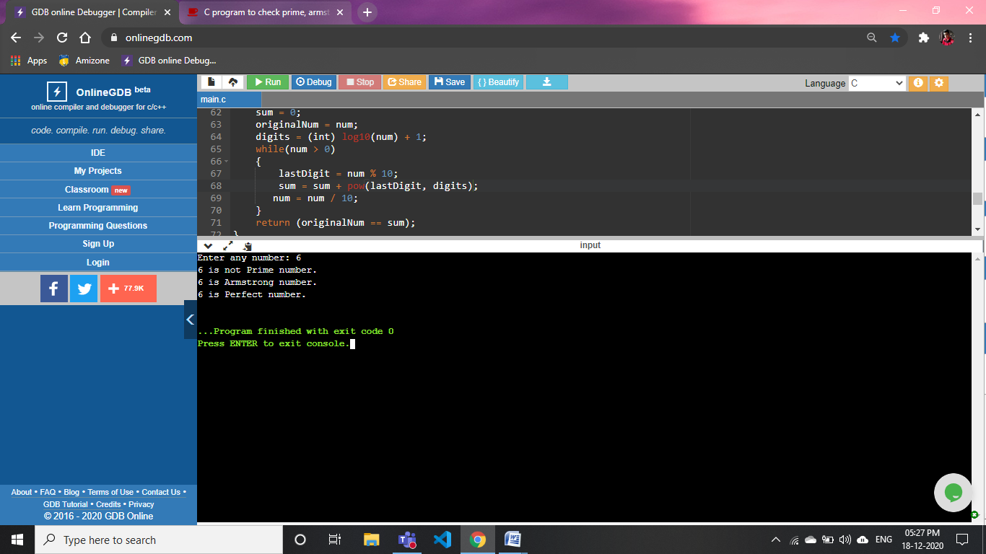

**: to print all strong numbers between given interval**

#include <stdio.h>

long long fact(int num);

void printStrongNumbers(int start, int end);

int main()

{

int start, end;

printf("Enter the lower limit to find strong number: ");

scanf("%d", &start);

printf("Enter the upper limit to find strong number: ");

scanf("%d", &end);

printf("All strong numbers between %d to %d are: \n", start, end);

printStrongNumbers(start, end);

return 0;

}

void printStrongNumbers(int start, int end)

{

long long sum;

int num;

while(start != end)

{

sum = 0;

num = start;

while(num != 0)

{

sum += fact(num % 10);

num /= 10;

}

if(start == sum)

{

printf("%d, ", start);

}

start++;

}

}

long long fact(int num)

{

if(num == 0)

return 1;

else

return (num * fact(num-1));

}

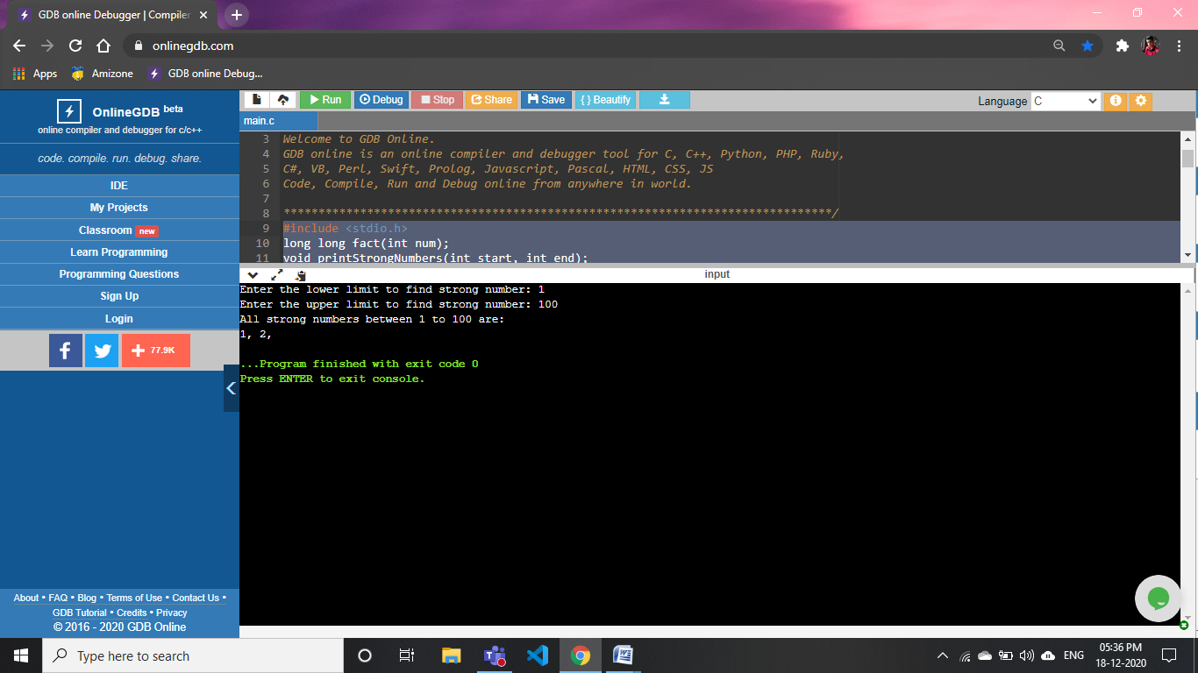

**47).Programs using recursion:**

**: to find the power of any number**

#include <stdio.h>

#include<math.h>

int power(int,int);

int main()

{

    int base, a, result;

    printf("Enter base number: ");

    scanf("%d", &base);

    printf("Enter power number(positive integer): ");

    scanf("%d", &a);

    result = power(base, a);

    printf("%d^%d = %d", base, a, result);

    return 0;

}

int power(int base, int a)

{

    if (a != 0)

        return (base * power(base, a - 1));

    else

        return 1;

}

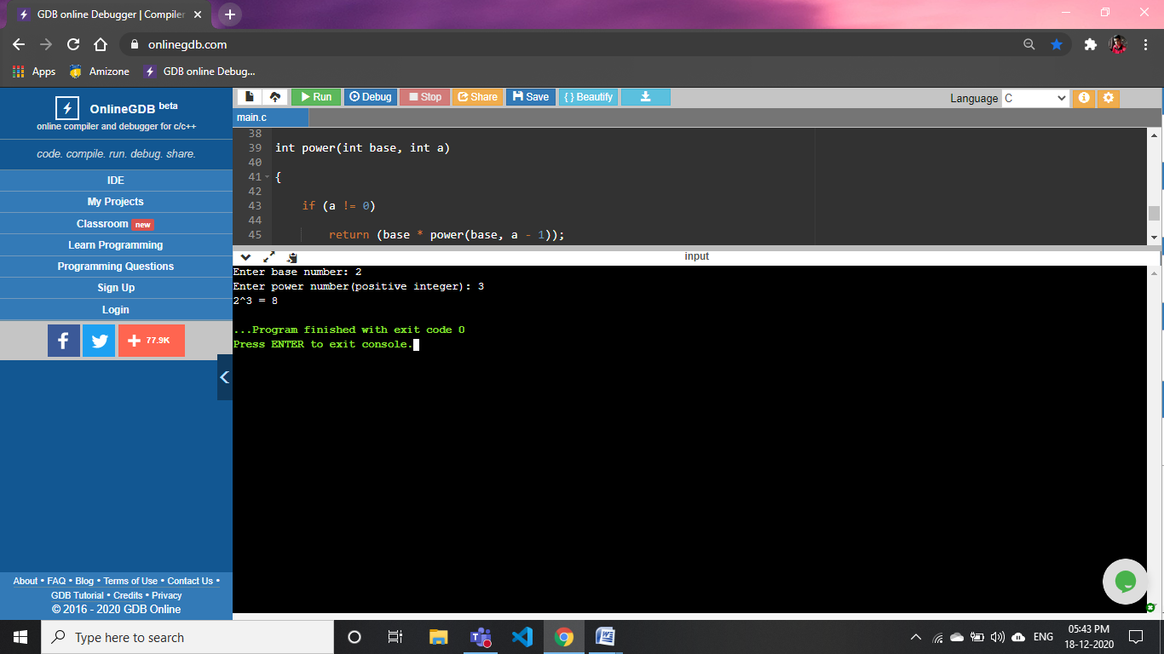

**: to print all the natural numbers between 1 to n**

#include <stdio.h>

int f(int a)

{

return a;

}

int main()

{

int i,a;

printf("Enter the last value till where u want to print natural no.\n");

scanf("%d",&a);

for(i=1;i<=a;i++)

{

printf(" %d,", f(i));

}

return 0;

}

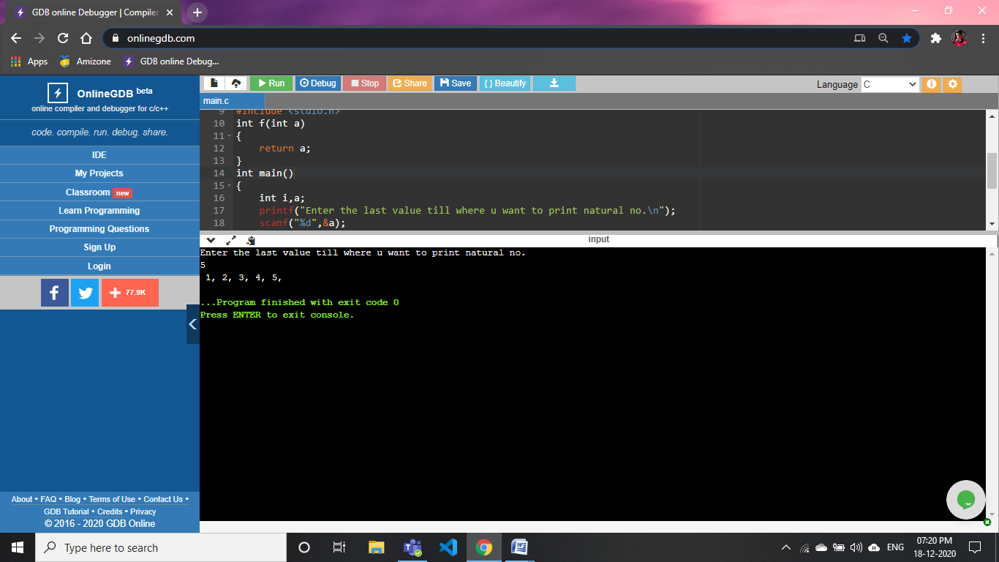

**48).WAP to compute the size of structure usinf sizeof operator**

 #include<stdio.h>

struct stud {

   int roll;

  char name;

   int marks;

};

int main()

{

   int size;

   struct stud s;

   size = sizeof(s);

   printf("Size of Structure : %d", size);

   return(0);

}

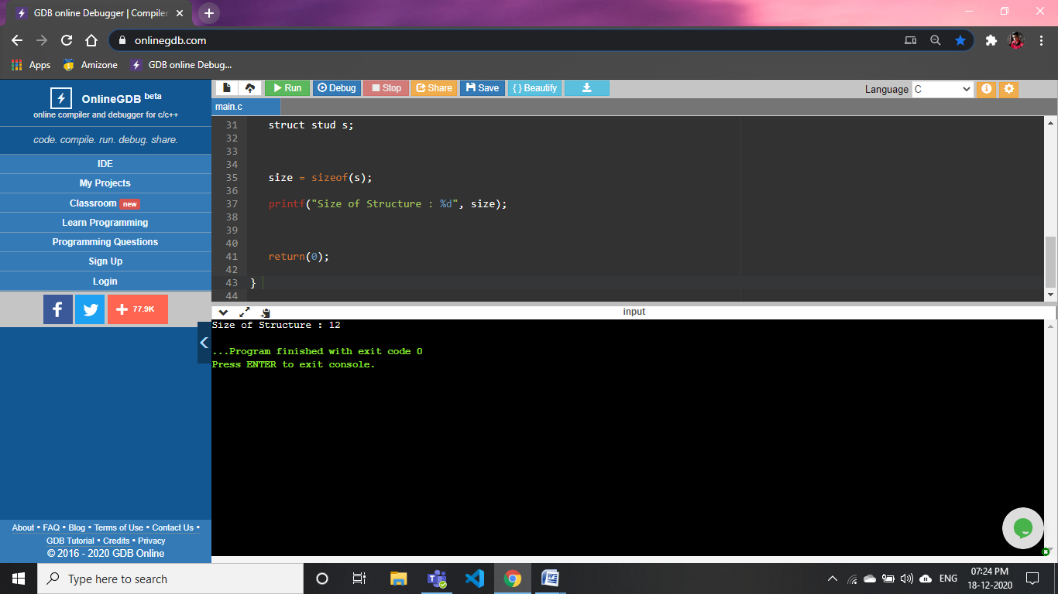

**49).WAP to store and display student information (Name, Roll Number & Marks) using structures**

#include <stdio.h>

struct student

{

  char name[50];

  int roll;

  int marks;

} s;

int

main ()

{

  printf ("Enter information:\n");

  struct student stdin;

  printf ("Enter name: ");

scanf("%c",&s.name);

  printf ("Enter roll number: ");

  scanf ("%d", &s.roll);

  printf ("Enter marks: ");

  scanf ("%d", &s.marks);

  printf ("Displaying Information:\n");

  printf ("Name: ");

  printf ("%s\n", s.name);

  printf ("Roll number: %d\n", s.roll);

  printf ("Marks: %d\n", s.marks);

  return 0;

}

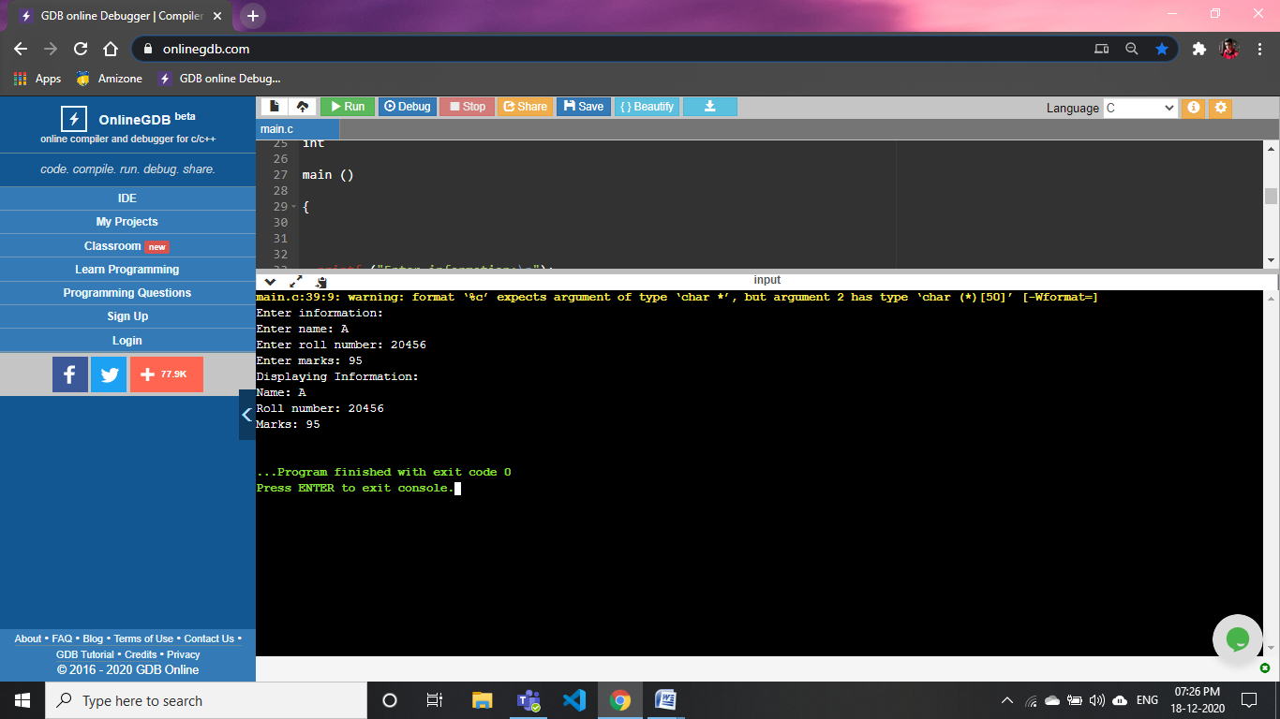

**50).WAP to store and print the student information (Name, Roll Number & Marks) using nested structures**

#include<stdio.h>

struct student

{

  char name;

  int roll;

  struct DOB

  {

    int date;

    int month;

    int year;

  };

};

int

main ()

{

  struct student s1;

  struct DOB s2;

  printf

    ("This is program of printing and storing details os student using nested structure\n");

  printf ("Enter name: ");

  scanf ("%c", &s1.name);

  printf ("Enter Roll No.: ");

  scanf ("%d", &s1.roll);

  printf ("Enter DOB: \n");

  printf ("Date: ");

  scanf ("%d", &s2.date);

  printf ("Month: ");

  scanf ("%d", &s2.month);

  printf ("Year: ");

  scanf ("%d", &s2.year);

  printf ("\n\nName=%c\n", s1.name);

  printf ("Roll no.=%d\n", s1.roll);

  printf ("DOB=%d/%d/%d", s2.date, s2.month, s2.year);

  return 0;

}

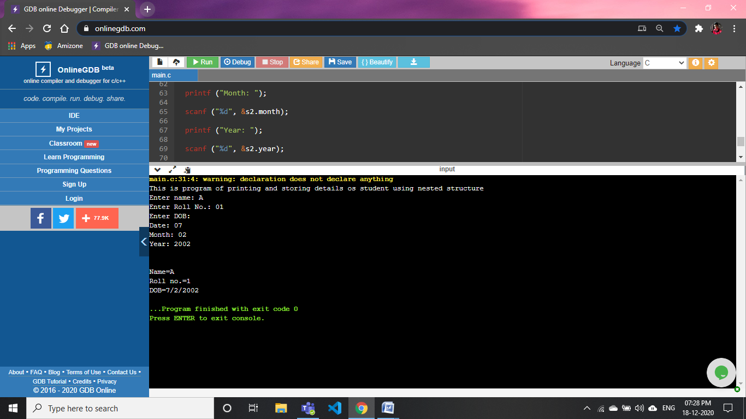

**51).WAP to store and print the record(Name, Roll Number & Percentage0 of 5 students usinf array of structure**

#include <stdio.h>

#include <string.h>

struct student

{

     char name[30];

     int roll;

     float percentage;

};

int main()

{

     int i;

     struct student record[2];

     record[0].roll=01;

     strcpy(record[0].name, "Anish");

     record[0].percentage = 96.5;

     record[1].roll=02;

     strcpy(record[1].name, "Aman");

     record[1].percentage = 90.5;

     record[2].roll=03;

     strcpy(record[2].name, "Aryan");

     record[2].percentage = 81.5;

     for(i=0; i<3; i++)

     {

         printf(" Records of STUDENT : %d \n", i+1);

         printf(" Roll no. is: %d \n", record[i].roll);

         printf(" Name is: %s \n", record[i].name);

         printf(" Percentage is: %f\n\n",record[i].percentage);

     }

     return 0;

}

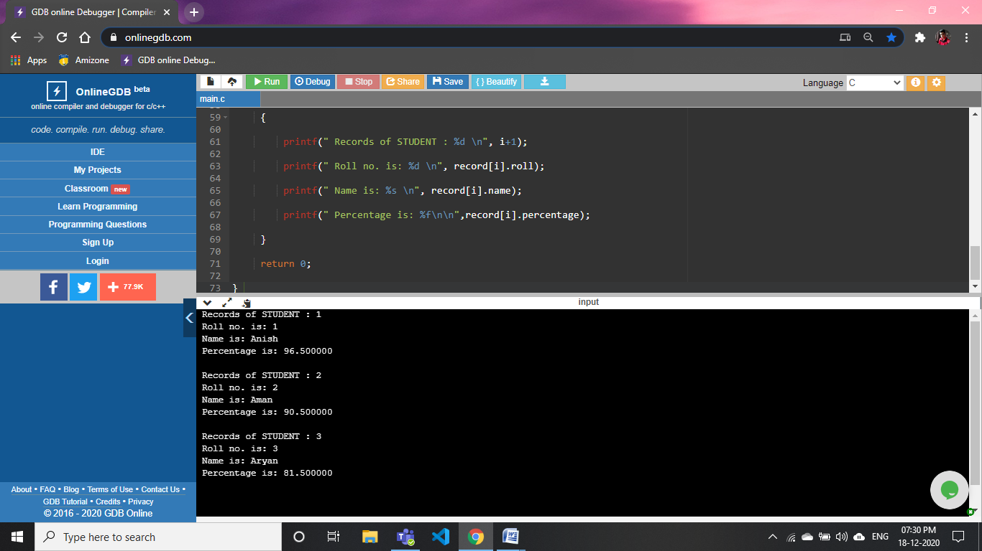

**52).WAP to create a structure called student to store the name roll number and marks of 3 students and calculate the average marks of each student**

#include<stdio.h>

struct student

{

  char name;

  int roll;

  struct marks

  {

    int marks1;

    int  marks2;

    int marks3;

  };

};

int

main ()

{

    int a,b;

  struct student s1;

  struct marks s2;

  printf

    ("This is program of print and storing marks with their name and average of the 3 subject's marks using nested structure\n");

  printf ("Enter name: ");

  scanf ("%c", &s1.name);

  printf ("Enter Roll No.: ");

  scanf ("%d", &s1.roll);

  printf ("Enter Marks of 3 subject: \n");

  printf ("Marks of 1st : ");

  scanf ("%d", &s2.marks1);

  printf ("Marks of 2nd : ");

  scanf ("%d", &s2.marks2);

  printf ("Marks of 3rd : ");

  scanf ("%d", &s2.marks3);

  a=s2.marks1+s2.marks2+s2.marks3;

  b=a/3;

  printf ("\n\nName=%c\n", s1.name);

  printf ("Roll no.=%d\n", s1.roll);

  printf ("Average of Three subject is :%d",b);

  return 0;

}

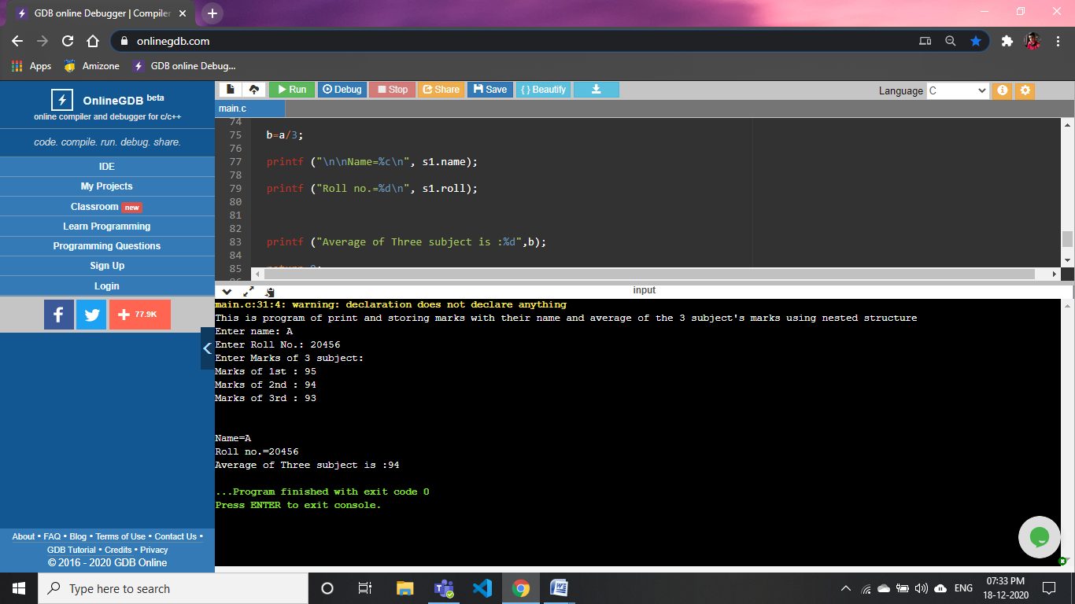

**53).WAP to perform the addition operation by passing structure members to functions**

#include<stdio.h>

struct add

{

    int a;

    int b;

};

int main()

{

    int b;

    struct add s1;

      printf("Enter two values to do adition:\n");

      printf("First :");

      scanf("%d",&s1.a);

      printf("Second: ");

      scanf("%d",&s1.b);

      b=func(s1.a,s1.b);

      printf("%d",b);

}

int func(int a,int b)

{

    int sum;

    sum=a+b;

    return sum;

}

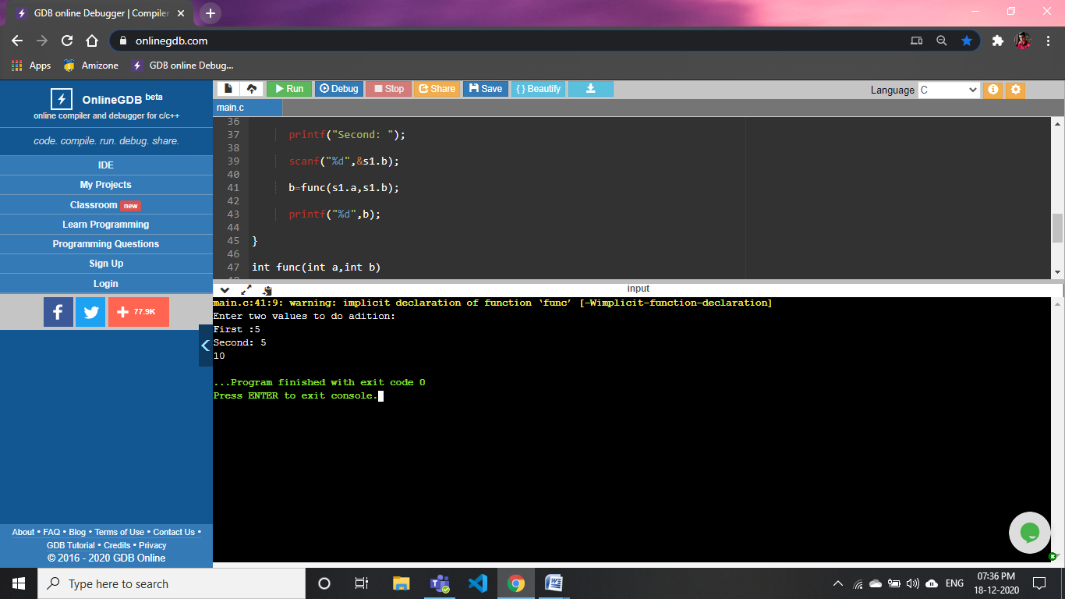

**54).WAP to declare and initialize a union**

#include<stdio.h>

union add

{

    int a;

    int b;

};

int main()

{

    union add s1;

    s1.a=10;

    s1.b=20;

    printf("a=%d\nb=%d",s1.a,s1.b);

}

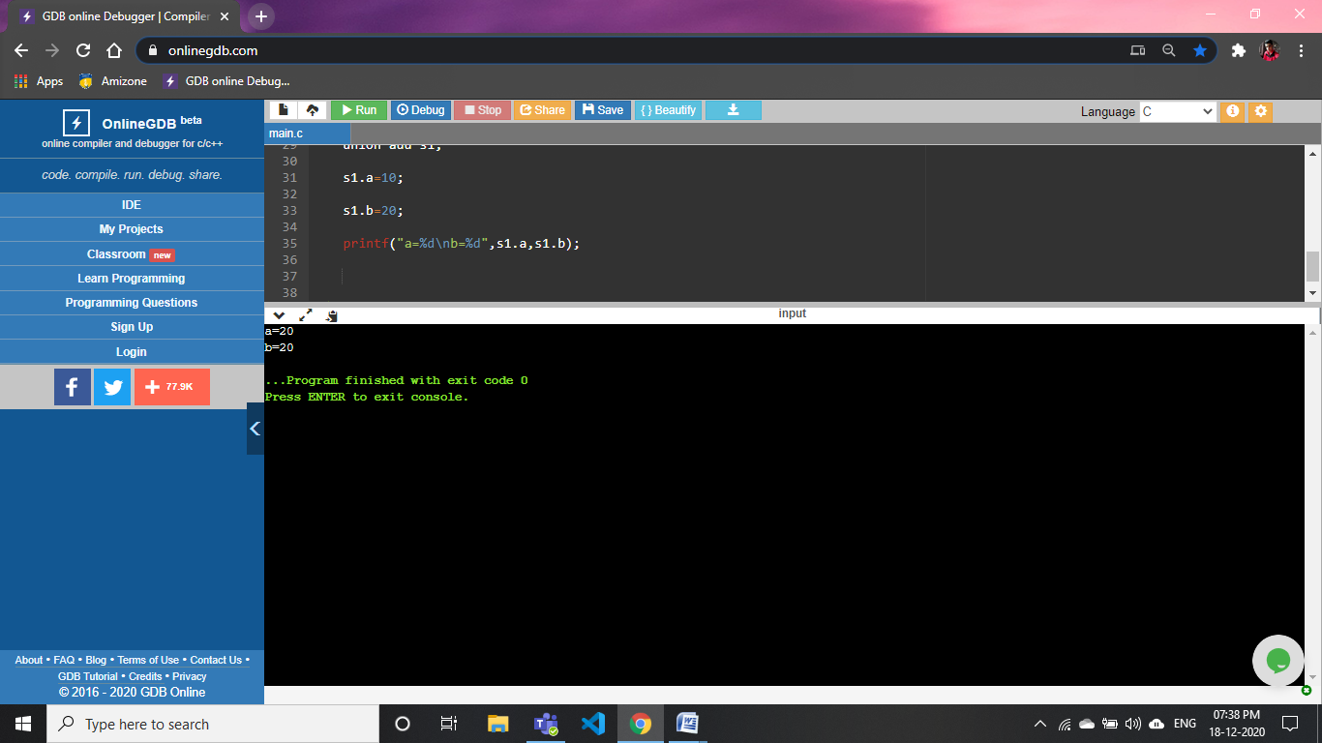

**55).WAP to find the area of rectangle using structures(write a function that accepts a structure rectangle and then computes the area)**

#include<stdio.h>

struct area

{

int l;

int b;

};

int fun(int a,int b)

{

int c;

c=a*b;

return c;

}

int main()

{

struct area s;

printf("Enter the lenght of rectangle : ");

scanf("%d",&s.l);

printf("Enter the breath of rectangle : ");

scanf("%d",&s.b);

printf("The area of rectangle=%d",fun(s.l,s.b));

return 0;

}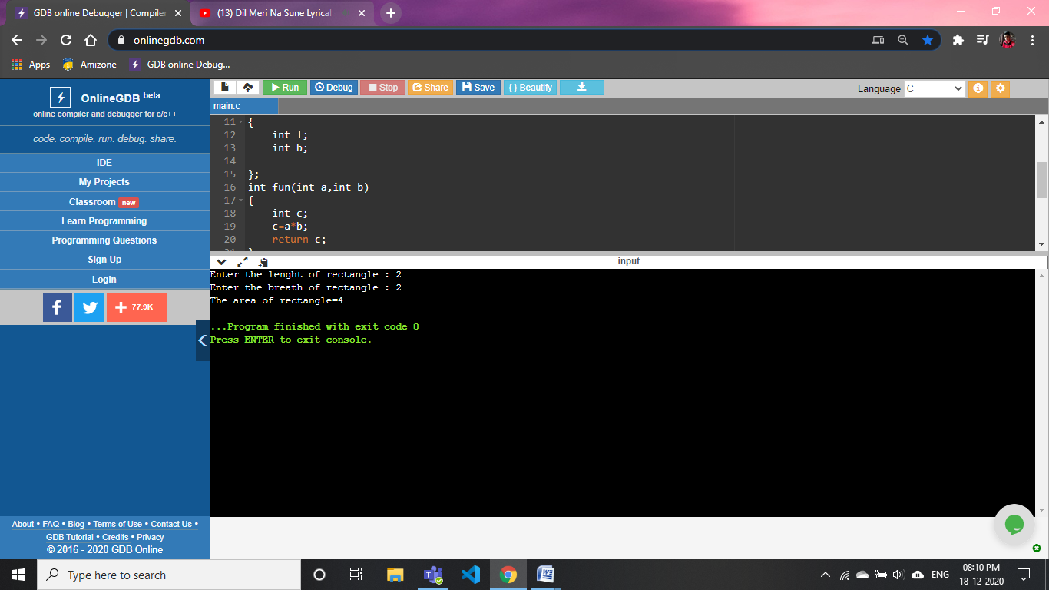

**56).WAP to use enum in switch case statemant to print which day is today. Consider the enum type named as week days, and it xcontains the name of all the seven days**

#include<stdio.h>

enum weekday{monday,tuesday,wednesday,thrusday,friday,saturday,sunday};

int main()

{

switch(4)

{

case 0:

printf("Today is monday");

break;

case 1:

printf("Today is tuesday");

break;

case 2:

printf("Today is wednesday");

break;

case 3:

printf("Today is thrusday");

break;

case 4:

printf("Today is friday");

break;

case 5:

printf("Today is saturday");

break;

case 6:

printf("Today is sunday");

}

}

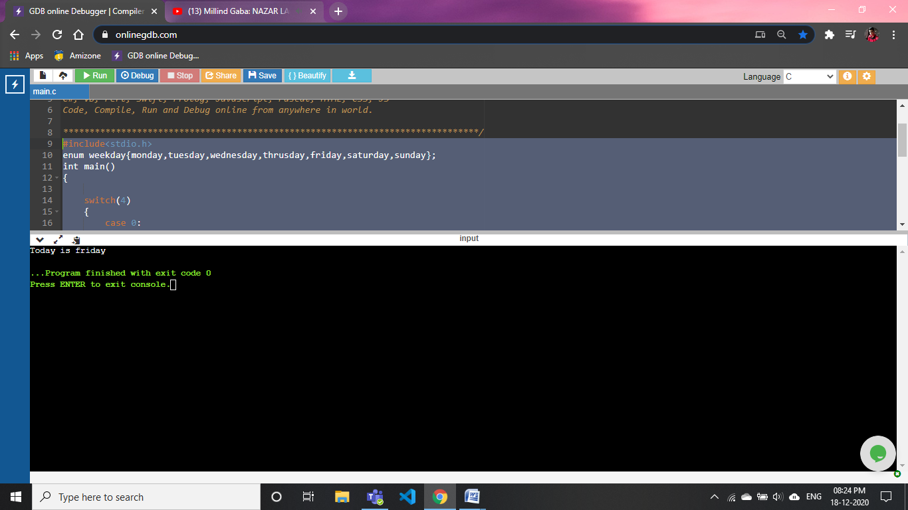

**57).WAP to create, initialize and use pointer variable and demeonstrate the use of & and *:**

#include<stdio.h>

int main()

{

int a;

int*p=&a;

printf("Enter the value of a: ");

scanf("%d",&a);

printf("The value is printing using pointer: %d",*(p));

return 0;

}

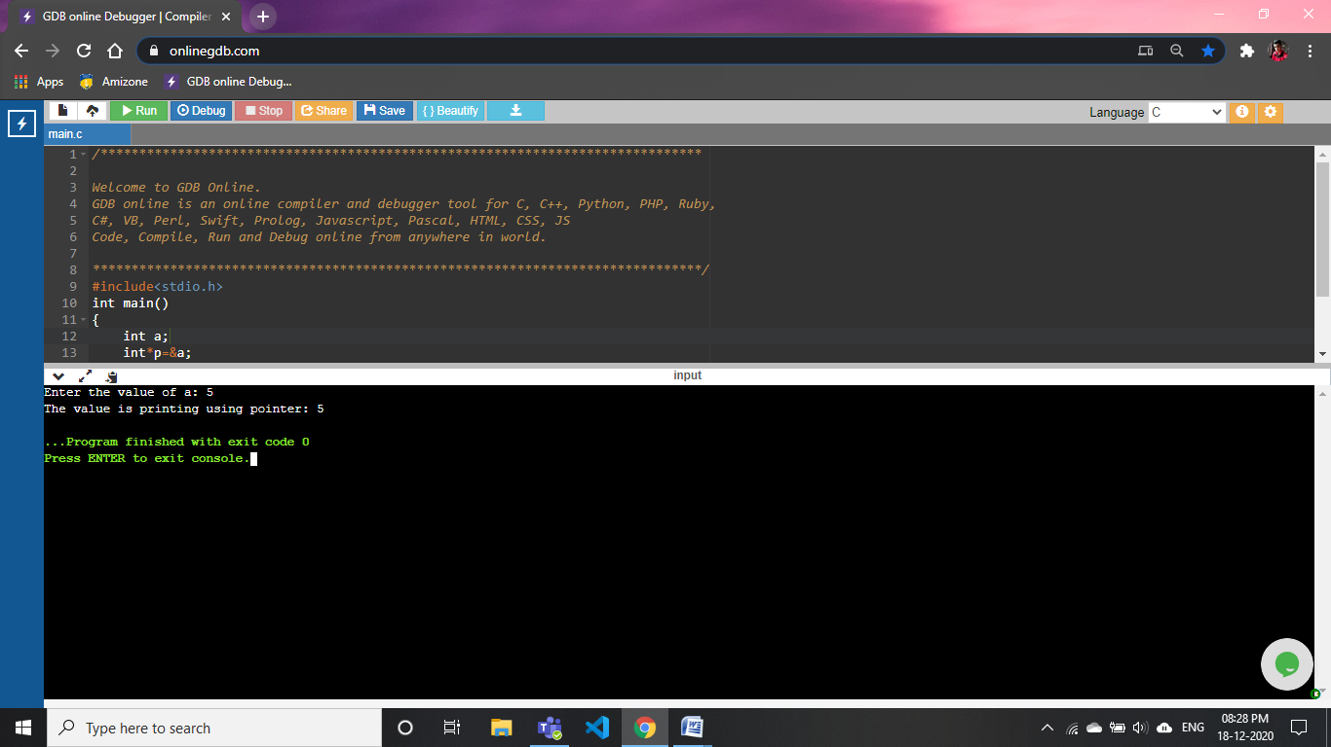

**58).WAP to perform arithmaetic operations using pointers**

#include<stdio.h>

int main()

{

int a;

int b;

int*p=&a;

int*q=&b;

printf("Enter the value of a: ");

scanf("%d",&a);

printf("Enter the value of b: ");

scanf("%d",&b);

printf("USing pointer\n");

printf("\na+b: %d",*(p)+*(q));

printf("\na-b: %d",*(p)-*(q));

printf("\naXb: %d",*(p)* *(q));

printf("\na/b: %d",*(p)/ *(q));

return 0;

}

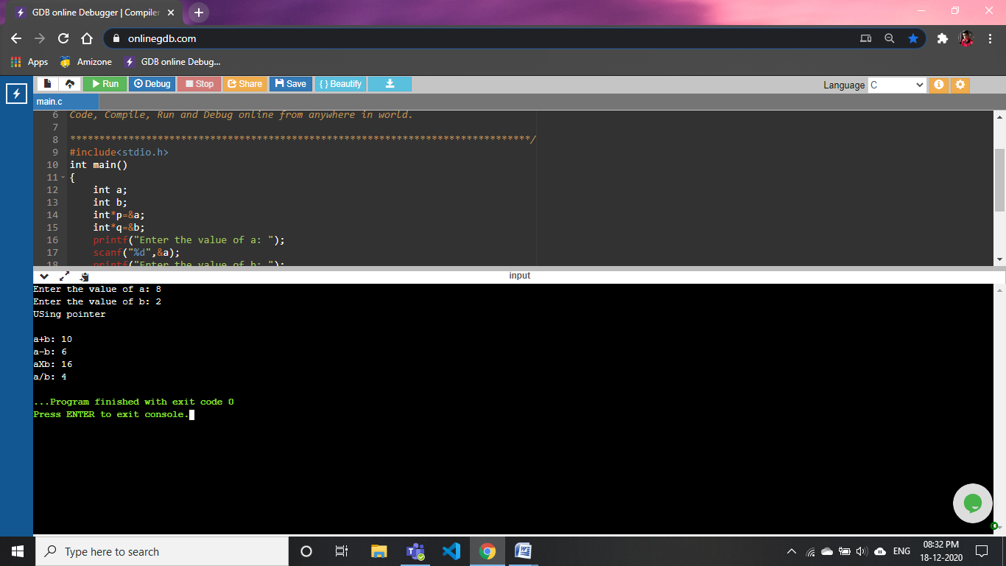

**59).WAP to find the area of square usig pointers**

#include<stdio.h>

int main()

{

int a;

int*p=&a;

printf("Enter the side of squre a: ");

scanf("%d",&a);

printf("Area of squre using pointer: %d",*(p)* *(p));

return 0;

}

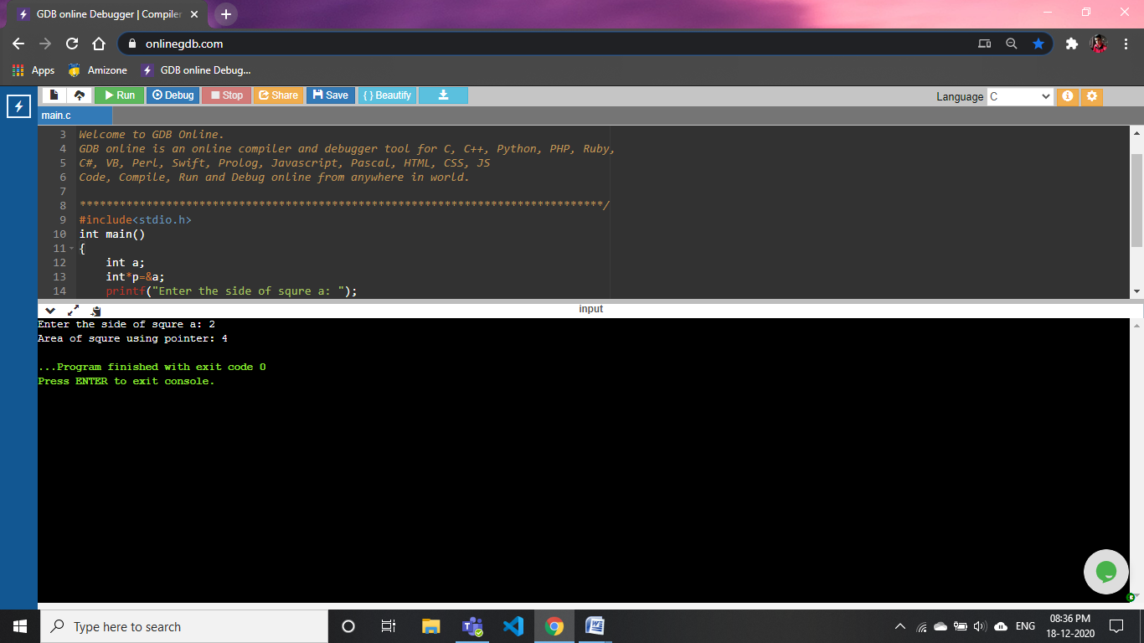

**60).WAP to reverse a number using pointers**

#include <stdio.h>

int main()

{

int n, rev = 0, remainder;

int*p=&n;

printf("Enter an integer: ");

scanf("%d", &n);

while (*(p) != 0)

{

remainder = *(p) % 10;

rev = rev * 10 + remainder;

*(p) =*(p)/ 10;

}

printf("Reversed number using pointer = %d", rev);

return 0;

}

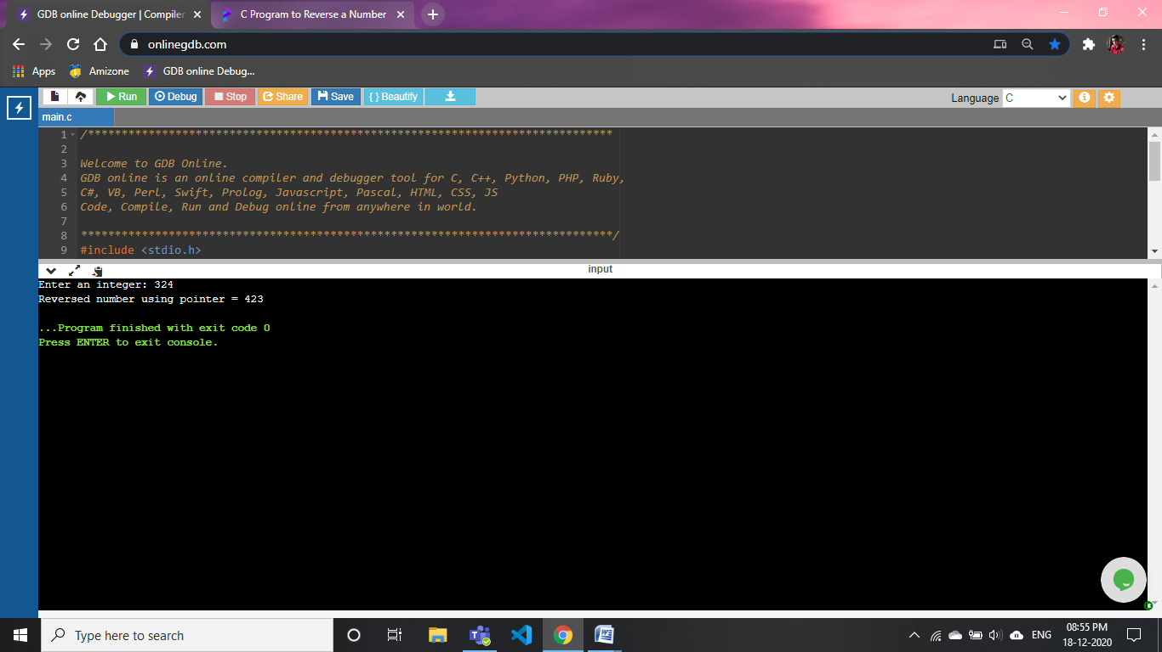

**61).WAP to print the factorial of an integer using pointers**

#include<stdio.h>

int main()

{

int i,f=1,num;

int*p=&num;

printf("Enter a number: ");

scanf("%d",&num);

for(i=1;i<=*(p);i++)

f=f*i;

printf("Factorial of %d using pointer is: %d",*(p),f);

return 0;

}

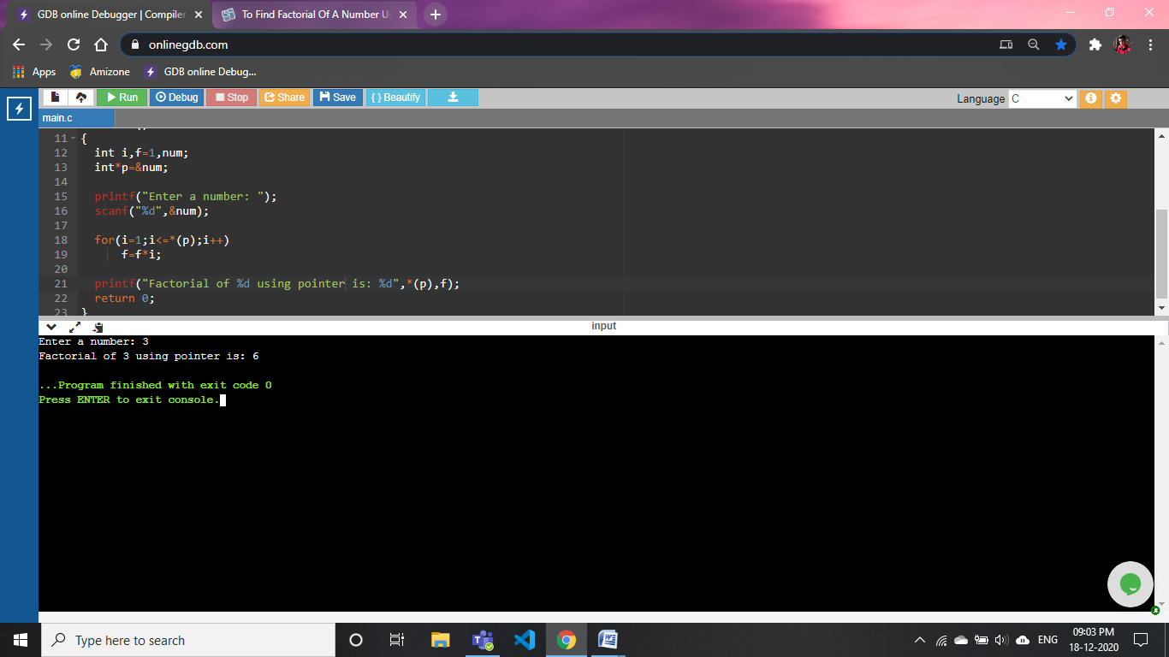

**62).WAP to input and print array element using pointers:**

#include <stdio.h>

#include<math.h>

int main()

{

int n,i;

printf("Enter The size of array: ");

scanf("%d",&n);

int a[n];

int*ptr=&a[n];

printf ("Pls enter %d element \n", n);

for (i = 0; i < n; i++)

{

scanf ("%d", &a[i]);

}

for (i = 0; i < n; i++)

{

printf("%d,", *(&a[i]));

}

return 0;

}

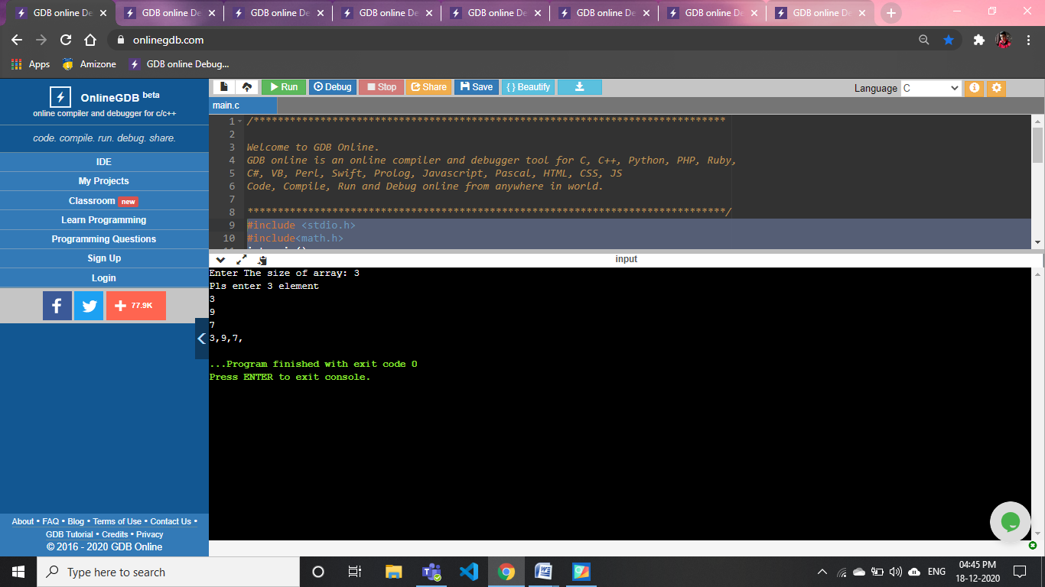

**63).WAP to illustrate pointer airthmetic:**

#include <stdio.h>

#include<math.h>

int main()

{

int a[2]={1,5};

int b[2]={2,2};

int*p=&a[1];

int*q=&b[1];

printf("a[1]=%d\nb[1]=%d",*(&a[1]),*(&b[1]));

printf("\nAirthmetic calculation using pointer:\n");

printf("a[1]+b[1]=%d",*(&a[1])+*(&b[1]));

printf("\na[1]-b[1]=%d",*(&a[1])-*(&b[1]));

printf("\na[1]++= %d,b[1]++= %d",*(&a[1]),*(&b[1]));

printf("\n++a[1]= %d,++b[1]= %d",*(&a[1])+1,*(&b[1])+1);

printf("\na[1]--= %d,b[1]--= %d",*(&a[1]),*(&b[1]));

printf("\n--a[1]= %d,--b[1]= %d",*(&a[1])-1,*(&b[1])-1);

return 0;

}

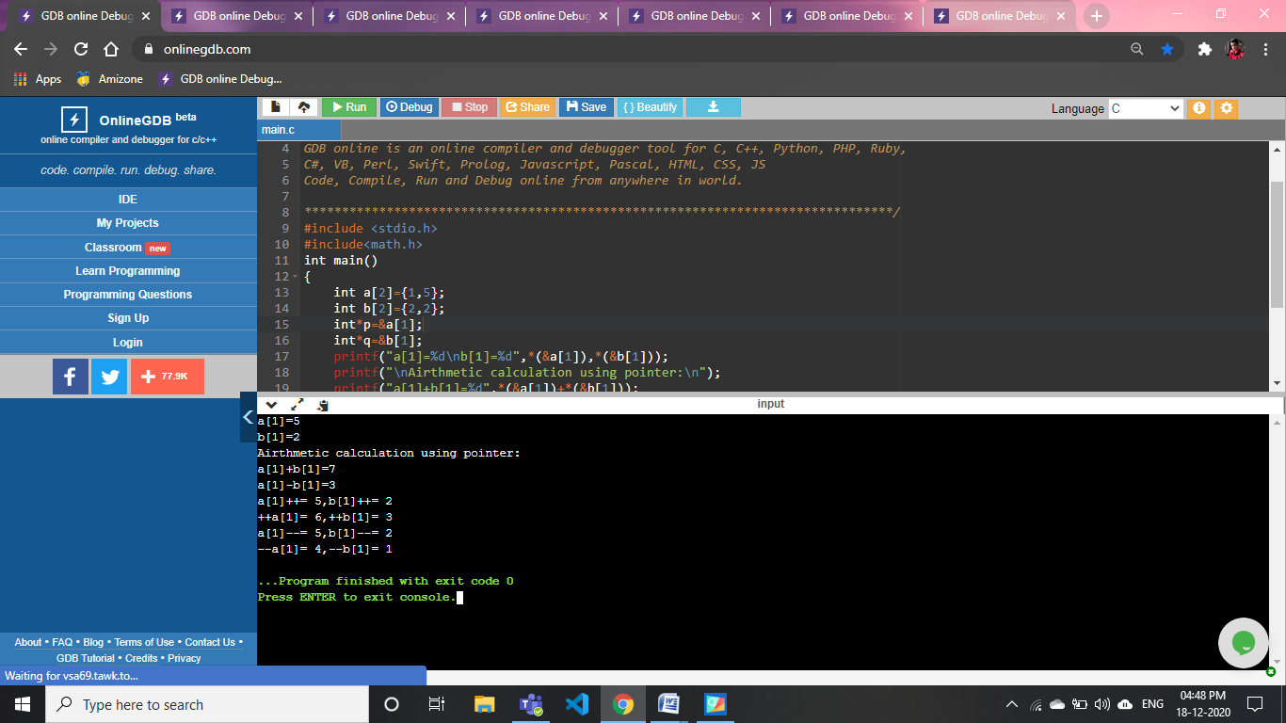

**64). WAP to find the sum of element of an array using pointer:**

#include <stdio.h>

int main()

{

int n,i,sum=0;

printf("Enter The size of array: ");

scanf("%d",&n);

int a[n];

int*ptr=&a[n];

printf ("Pls enter %d element \n", n);

for (i = 0; i < n; i++)

{

scanf ("%d", &a[i]);

}

for (i = 0; i < n; i++)

{

sum= sum + *(&a[i]);

}

printf("Sum of All element in array=%d",sum);

return 0;

}

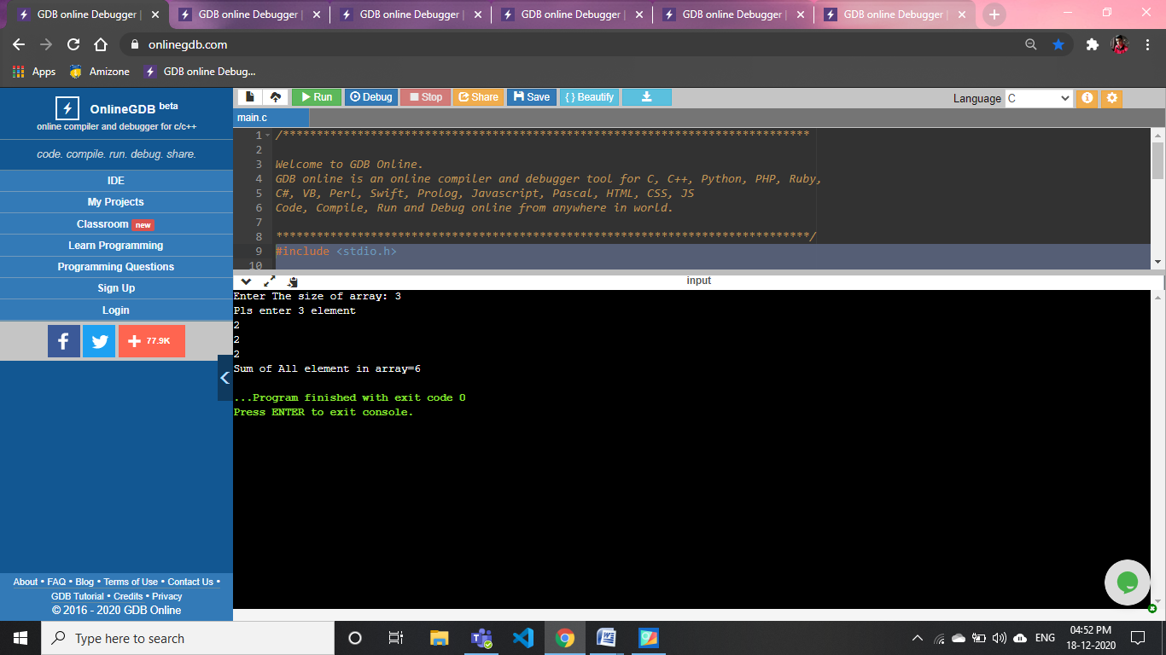

**65). WAP to reverse the series of a no. Using pointer:**

#include <stdio.h>

int main()

{

int n,i;

printf("Enter The size of array: ");

scanf("%d",&n);

int a[n];

int*ptr=&a[n];

printf ("Pls enter %d element to reverse\n", n);

for (i = 0; i < n; i++)

{

scanf ("%d", &a[i]);

}

for (i = 0; i < n; i++)

{

printf("%d,", *(&a[i]));

}

printf("\nThe reverse of array\n");

for (i = n-1; i >= 0; i--)

{

printf("%d,", *(&a[i]));

}

return 0;

}

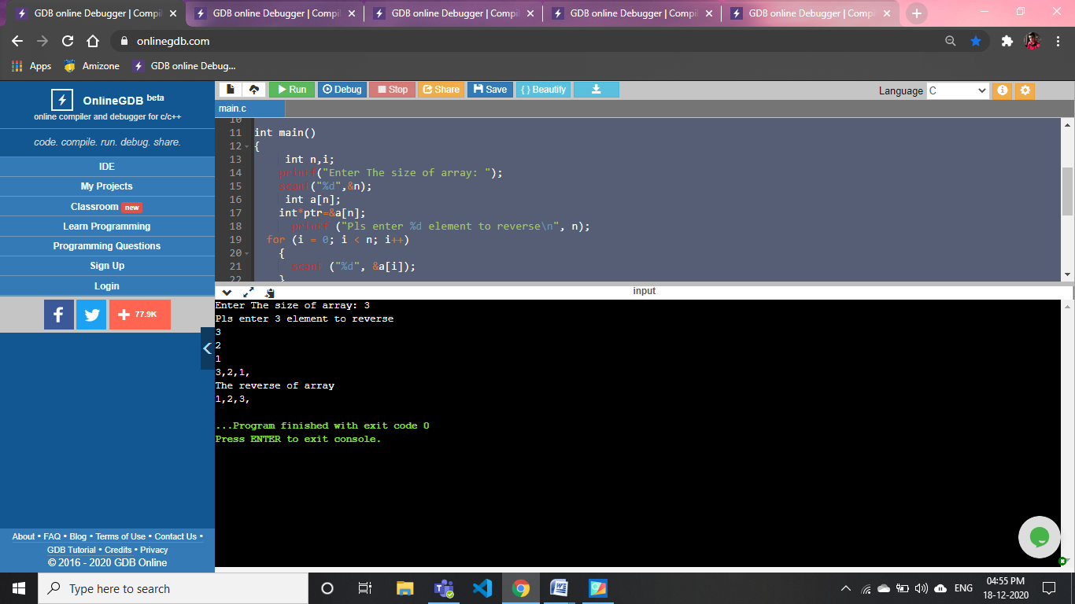

**66). WAP to search for an element in array using pointer**:

#include <stdio.h>

int main()

{

int n,i,p,value;

printf("Enter The size of array: ");

scanf("%d",&n);

int a[n];

int*ptr=&a[n];

printf ("Pls enter %d element to acces any element\n", n);

for (i = 0; i < n; i++)

{

scanf ("%d", &a[i]);

}

for (i = 0; i < n; i++)

{

printf("%d,", *(&a[i]));

}

printf("\nEnter the the element which u want to acces\n");

scanf("%d", &p);

for (i= n- 1; i >= p - 1; i--)

a[i+1] = a[i];

a[p-1] = p;

printf("This element you want to acces = %d\n",p);

return 0;

}

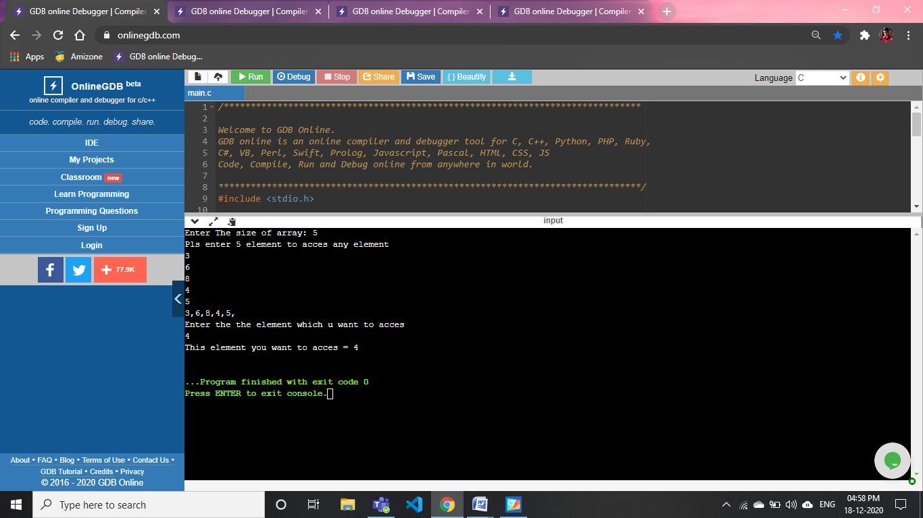

**67). WAP to find the area of circle using pointer and function:**

#include <stdio.h>

float fun(float*p)

{

float area;

area=3.14*(*p)*(*p);

return area;

}

int main()

{

float a,c;

float*p=&a;

printf("Enter the radius of circle to find its area\n");

scanf("%f",&a);

c=fun(&a);

printf("area=%f",c);

return 0;

}

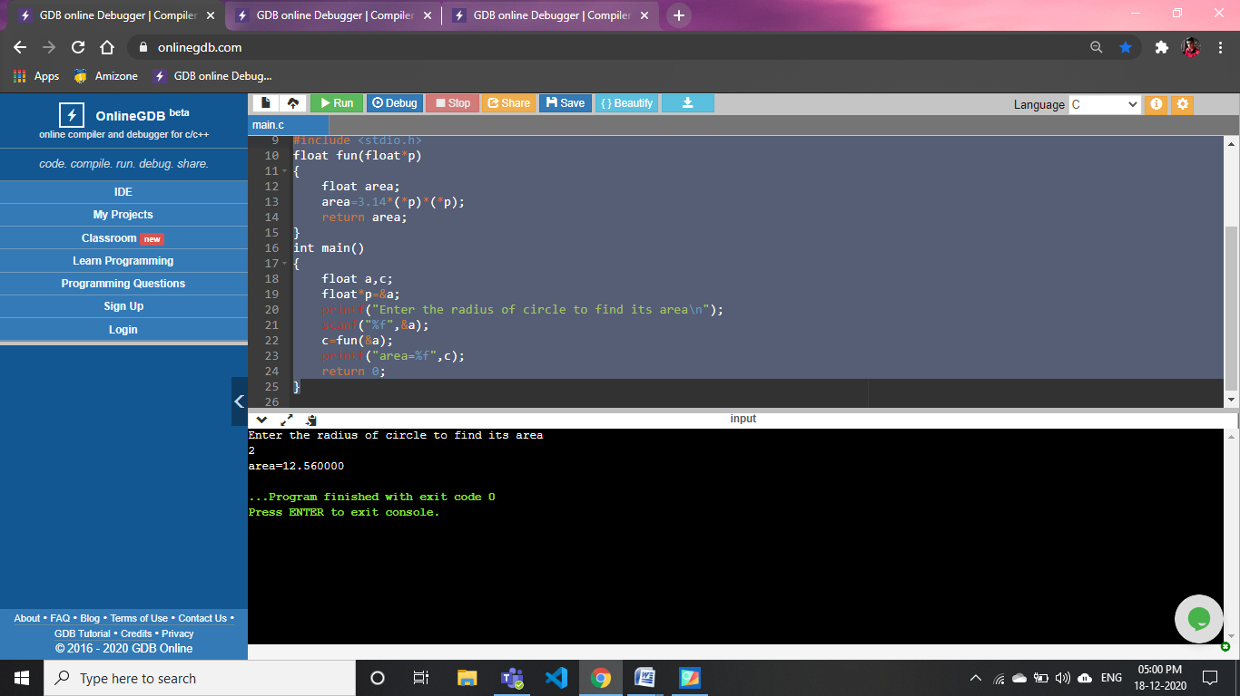

**68).WAP to access the element of structure using structure pointer:**

#include <stdio.h>

struct abc

{

int a;

int b;

};

int main()

{

struct abc s;

int*p=&s.a;

int*q=&s.b;

printf("Enter the values of a and b :\n");

printf("a= ");

scanf("%d",*(&p));

printf("b= ");

scanf("%d",*(&q));

printf("The values of a: %d and b: %d using pointer and structure datatype: ",s.a,s.b);

return 0;

}

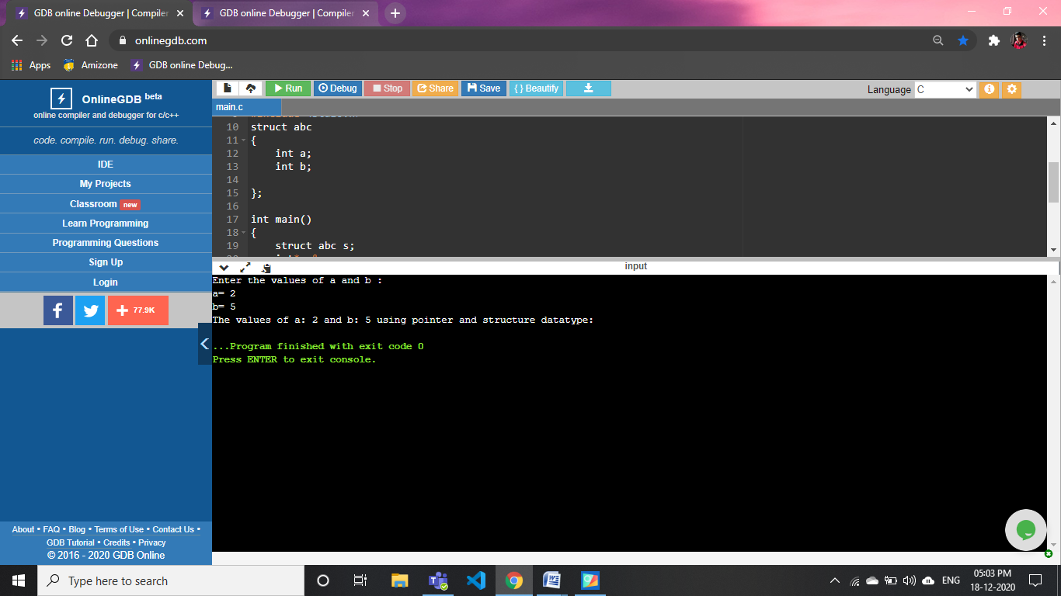

***Made by:- Anish Kumar Singh***

***Thank you....***